UC09-SSW-UT-NTE-N002-000019



Notice of water main diversion works – A453 Sutton Road

Location
A453 Sutton Road, Drayton Bassett, Tamworth, B78 3DZ.

Duration
Works will commence on 26 October 2026 and will be completed in December 2026.

What we are doing
South Staffs Water will be diverting an existing water main along the A453, Sutton Road.

What to expect
The work will be completed off the highway in areas of land already fenced off for ongoing HS2 works.

This work will not have an impact on traffic in the area.

Access to any properties potentially affected by the works will be maintained throughout.
We are committed to keeping you informed about work on HS2. This includes ensuring you know what to expect and when to expect it, as well as how we can help you. Should you have any questions or concerns about our works you can contact us by:


Freephone 08081 434 434

Minicom 08081 456 472

Email HS2enquiries@hs2.org.uk
Writing to FREEPOST
HS2 Community Engagement


Website www.hs2.org.uk

Keep up to date with what is happening in your local area at
www.hs2.org.uk/in-your-area/
in-your-area-map/

Additional information
To complete the works safely, works will be completed off highway in areas of land already fenced off for ongoing HS2 works, as well as within the verges of Sutton Road.

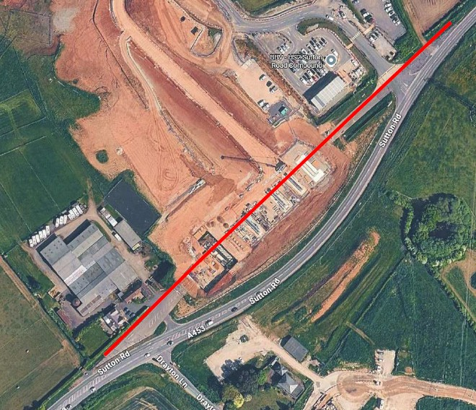

Please contact us if you’d like a free copy of this document in large print, Braille, audio or ‘easy read’ format. You can also contact us for help and information in a different language.
Holding us to account
If you are unhappy for any reason, you can make a complaint by contacting our HS2 Helpdesk team. For more information, visit: www.hs2.org.uk/how-to-complain
We have an independent Residents’ and Construction Commissioner who helps settle disputes and monitors the way in which we manage and respond to complaints about construction.
For more information visit: www.hs2.org.uk/independent-commissioner

