HS2-BBV-26-2668



Notice of road closure on B4113 Stoneleigh Road and Stareton Lane, Stoneleigh

Location
B4113 Stoneleigh Road and Stareton Lane, Stoneleigh, near Stoneleigh Park

Duration
The road closures will be in place 24 hours a day, seven days a week, from Thursday 26 November to Thursday 24 December 2026

What we are doing
We will be carrying out a series of further road drainage, lighting, earthworks and access improvements to Stoneleigh Park. These works will be carried out in three phases please see maps for further details

What to expect
Access to properties, businesses and into Stoneleigh Park will be maintained. It is not possible to provide a safe pedestrian or cycle route through the works. A fully signed road diversion will be in place.
We are committed to keeping you informed about work on HS2. This includes ensuring you know what to expect and when to expect it, as well as how we can help you. Should you have any questions or concerns about our works you can contact us by:


Freephone 08081 434 434

Minicom 08081 456 472

Email HS2enquiries@hs2.org.uk
Writing to FREEPOST
HS2 Community Engagement


Website www.hs2.org.uk

Keep up to date with what is happening in your local area at
www.hs2.org.uk/in-your-area/
in-your-area-map/

Where we will be working
Phase One: Friday 26 November to Sunday 29 November 2026
Stoneleigh Road and Stareton Lane will be closed. Access to Stoneleigh Park will be maintained via the B4113 from the Leamington side of the road closure.
Phase Two: Monday 30 November to Thursday 10 December 2026
Stoneleigh Road will be closed on the Leamington side of the B4113. Access to Stoneleigh Park will be available via Stoneleigh Village and Stareton Lane.
Phase Three: Friday 11 December to Wednesday 23 December 2026
Stoneleigh Road and Stareton Lane will be closed. Access to Stoneleigh Park will be maintained via the B4113 from the Leamington side of the road closure.

Map showing Phase one and three closure B4113 Stoneleigh Road and Stareton Lane road closures with the diversion route.
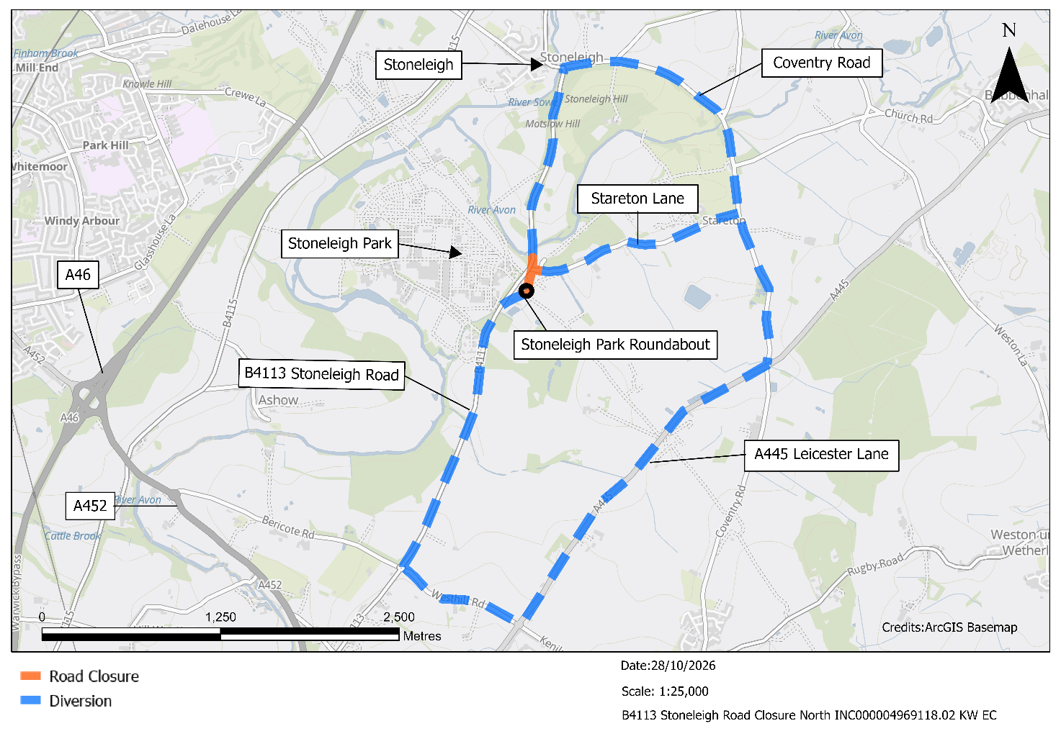

Map showing Phase two closure B4113 Stoneleigh Road and Stareton Lane road open with the diversion route
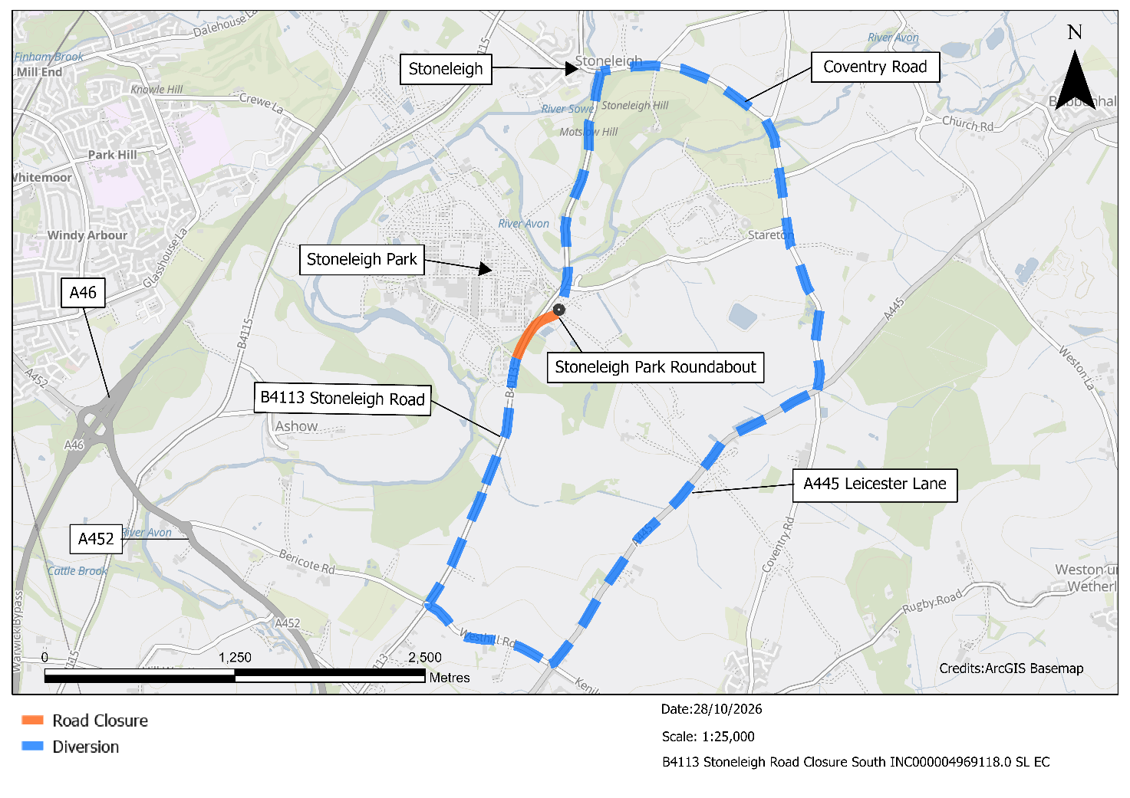

Useful information

The diversion route in place is suitable for all types of vehicles including HGVs, other roads in the area have a narrow bridge and are not suitable for larger vehicles.

For information regarding public bus routes scan the QR code or visit https://bustimes.org/

HS2/BBV Drop-in events near you
We would like to invite you to our next HS2 Drop-in events in the area, where you can come and chat with your local Community Engagement Team. At these events you will be able to talk to our experts about our work, engineering, construction and the environment; any queries you may have and community investment opportunities.



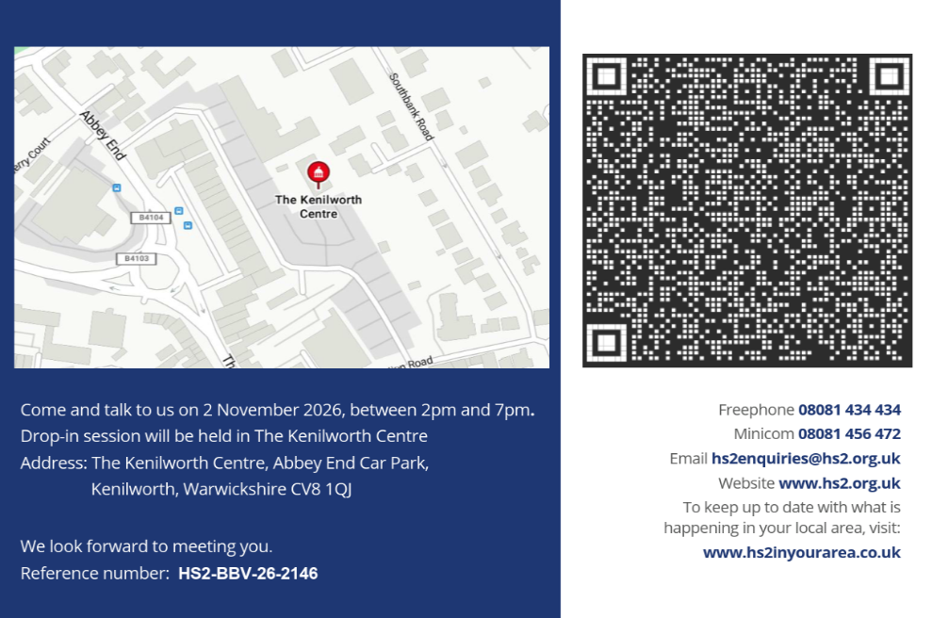



If you would like to find out more about the latest works and our community projects in your area - scan the QR code for our newsletter.

Please contact us if you’d like a free copy of this document in large print, Braille, audio or ‘easy read’ format. You can also contact us for help and information in a different language.
Holding us to account
If you are unhappy for any reason, you can make a complaint by contacting our HS2 Helpdesk team. For more information, visit: www.hs2.org.uk/how-to-complain
We have an independent Residents’ and Construction Commissioner who helps settle disputes and monitors the way in which we manage and respond to complaints about construction.
For more information visit: www.hs2.org.uk/independent-commissioner

