HS2-BBV-26-2105


UPDATED: Notice of overnight closures of A45 Coventry Road eastbound and westbound carriageways (including East Way)

Location
A45 Coventry Road eastbound and westbound including East Way near Bickenhill.

Duration
Overnight closures: Each night from Tuesday 26 May 2026 until Tuesday 2 June 2026 between 9pm and 6am

The final overnight shift for these works will begin on Monday 1 June 2026 and conclude at 6am on Tuesday 2 June 2026

What we are doing
As work progresses on the A45 Coventry Road overbridge in Solihull, overnight traffic management will be required to ensure the safe installation of beams.

What to expect
Low level noise from our works site.
A fully signed diversion route during each. closure.
These works are subject to consent.
We are committed to keeping you informed about work on HS2. This includes ensuring you know what to expect and when to expect it, as well as how we can help you. Should you have any questions or concerns about our works you can contact us by:


Freephone 08081 434 434

Minicom 08081 456 472

Email HS2enquiries@hs2.org.uk
Writing to FREEPOST
HS2 Community Engagement


Website www.hs2.org.uk

Keep up to date with what is happening in your local area at
www.hs2.org.uk/in-your-area/
in-your-area-map/

A45 Coventry Road eastbound diversion route
During each overnight closure, road users should follow the fully signed diversion route and allow extra time for their journeys.

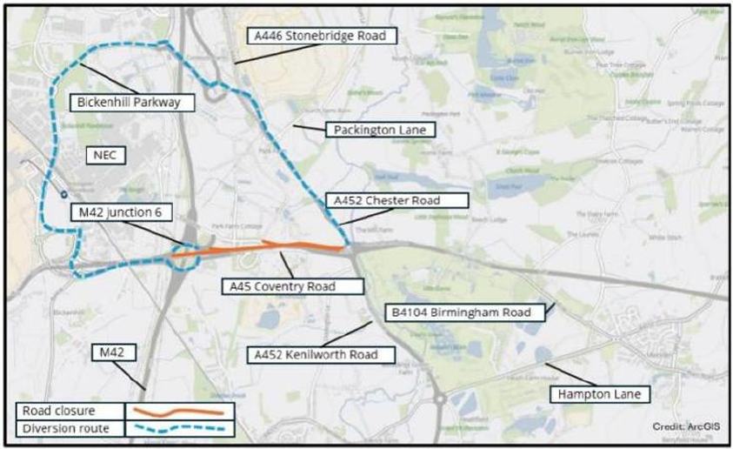

A45 Coventry Road westbound diversion route
During each overnight closure, road users should follow the fully signed diversion route and allow extra time for their journeys.

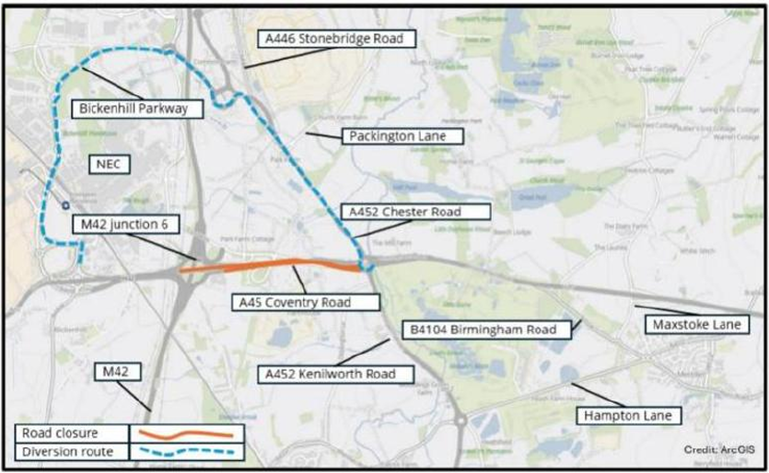

Please contact us if you’d like a free copy of this document in large print, Braille, audio or ‘easy read’ format. You can also contact us for help and information in a different language.
Holding us to account
If you are unhappy for any reason, you can make a complaint by contacting our HS2 Helpdesk team. For more information, visit: www.hs2.org.uk/how-to-complain
We have an independent Residents’ and Construction Commissioner who helps settle disputes and monitors the way in which we manage and respond to complaints about construction.
For more information visit: www.hs2.org.uk/independent-commissioner

