HS2-BCZ – SCP-26-2084



Installation of tower crane -Curzon St station

Location
Curzon Street

Duration
Saturday 4 July – Sunday 5 July

What we are doing
Installation of the second of four large tower cranes on site.

What to expect
We will put the tower crane together on site using a mobile crane. HGVs will deliver the components of the crane during normal working hours and on Sunday (8am – 6pm) They will arrive on site on Friday, and we will assemble over the weekend. Once we complete the assembly of the tower crane, we will dismantle and remove the mobile crane from site.

We are committed to keeping you informed about work on HS2. This includes ensuring you know what to expect and when to expect it, as well as how we can help you. Should you have any questions or concerns about our works you can contact us by:


Freephone 08081 434 434

Minicom 08081 456 472

Email HS2enquiries@hs2.org.uk
Writing to FREEPOST
HS2 Community Engagement


Website www.hs2.org.uk

Keep up to date with what is happening in your local area at
www.hs2.org.uk/in-your-area/
in-your-area-map/

Additional information
For safety reasons, we can only install the tower cranes during good weather. If weather conditions are not suitable, this will impact on the installation dates. Two further tower cranes will be delivered and assembled later in July and October. You may see our operatives walking on the cranes while they are being assembled. Once the tower cranes are in place, they will be operational during normal core working hours.

We recognise that construction work can be disruptive to those living or working nearby. The nature of our work often means some disturbance is unavoidable. We will make every effort to minimise any unnecessary noise. We will closely monitor all noise, vibration, and dust levels to ensure we do not exceed our agreed limits.

Where we will be working
Please see image below showing aerial view Curzon Street site – Tower Crane 2 will be the crane that is to be installed.

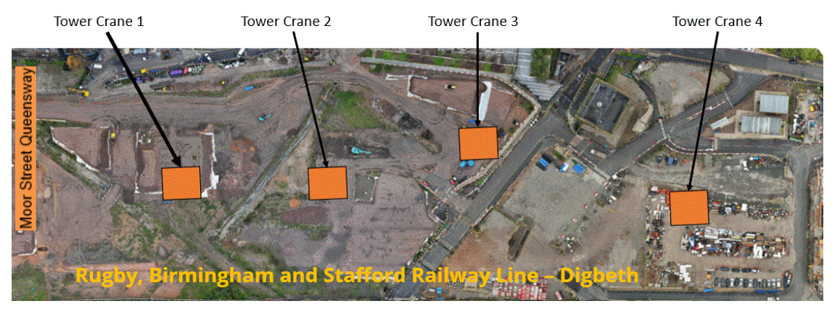

Please contact us if you’d like a free copy of this document in large print, Braille, audio or ‘easy read’ format. You can also contact us for help and information in a different language.
Holding us to account
If you are unhappy for any reason, you can make a complaint by contacting our HS2 Helpdesk team. For more information, visit: www.hs2.org.uk/how-to-complain
We have an independent Residents’ and Construction Commissioner who helps settle disputes and monitors the way in which we manage and respond to complaints about construction.
For more information visit: www.hs2.org.uk/independent-commissioner

