HS2-BCZ – SCP-26-2081



Pedestrian gate installation for site accommodation -Curzon St station

Location
Curzon Street

Duration
Thursday 21 May to Monday 8 June which may include some Saturday working

What we are doing
Installing a new set of double pedestrian gates to facilitate access to the new site accommodation. Which will be located to the right of the Woodman Pub by the seating area, which will remain open.

What to expect
We will need to partly close the footpath to safely install the new gate. We will put temporary barriers in place to maintain safety. We will not dismantle the existing hoarding is taking place.

We are committed to keeping you informed about work on HS2. This includes ensuring you know what to expect and when to expect it, as well as how we can help you. Should you have any questions or concerns about our works you can contact us by:


Freephone 08081 434 434

Minicom 08081 456 472

Email HS2enquiries@hs2.org.uk
Writing to FREEPOST
HS2 Community Engagement


Website www.hs2.org.uk

Keep up to date with what is happening in your local area at
www.hs2.org.uk/in-your-area/
in-your-area-map/

Additional information

We recognise that construction work can be disruptive to those living or working nearby. The nature of our work often means some disturbance is unavoidable. We will make every effort to minimise any unnecessary noise. We will closely monitor all noise, vibration, and dust levels to ensure we do not exceed our agreed limits.

Where we will be working
Please see image below showing map showing area of work

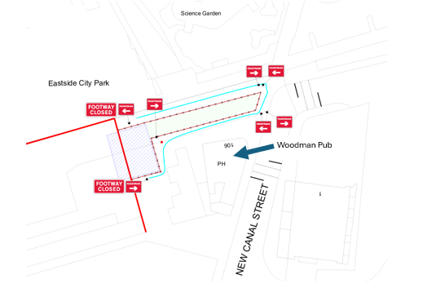

Please contact us if you’d like a free copy of this document in large print, Braille, audio or ‘easy read’ format. You can also contact us for help and information in a different language.
Holding us to account
If you are unhappy for any reason, you can make a complaint by contacting our HS2 Helpdesk team. For more information, visit: www.hs2.org.uk/how-to-complain
We have an independent Residents’ and Construction Commissioner who helps settle disputes and monitors the way in which we manage and respond to complaints about construction.
For more information visit: www.hs2.org.uk/independent-commissioner

