HS2-BBV-26-2104



Temporary daytime and overnight traffic management on A452 Chester Road northbound/ southbound and Packington Lane

Location
A452 Chester Road southbound off slip/Packington Lane, and A452 Chester Road northbound carrigeway

Duration
Off-peak daytime A452 Chester Road southbound off-slip, including Packington Lane southbound access:
From Monday 1 June 2026 to Tuesday 2 June 2026 between 9.30am and 3.30pm

Packington Lane access via the A452 Chester Road northbound
From Wednesday 3 June 2026 to Thursday 4 June 2026 between 9am and 6pm:

Overnight closure of A452 Chester Road northbound
Monday 8 June 2026 10pm and 6.00am

What we are doing
Traffic management will be in place to allow our workforce to safely carry out essential activities.

What to expect
low-level noise from our works site.
A fully signed diversion route.
These works are subject to consent.
We are committed to keeping you informed about work on HS2. This includes ensuring you know what to expect and when to expect it, as well as how we can help you. Should you have any questions or concerns about our works you can contact us by:


Freephone 08081 434 434

Minicom 08081 456 472

Email HS2enquiries@hs2.org.uk
Writing to FREEPOST
HS2 Community Engagement


Website www.hs2.org.uk

Keep up to date with what is happening in your local area at
www.hs2.org.uk/in-your-area/
in-your-area-map/

Off-peak daytime A452 Chester Road off-slip, including Packington Lane southbound access diversion
Please follow the fully signed diversion route and allow more time for your journeys.

Access to Packington Lane:
Access to Packington lane during the off-peak daytime closures will be via the A452 northbound only.

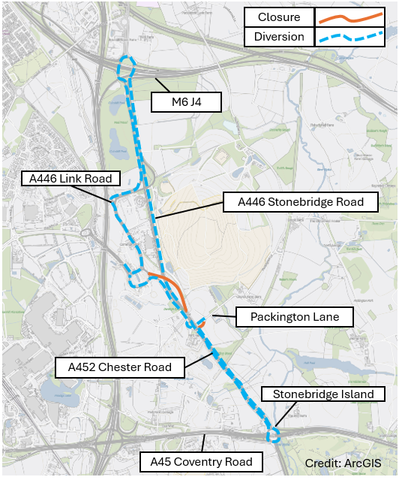

Packington Lane access via the A452 Chester Road northbound diversion
Please follow the fully signed diversion route and allow more time for your journeys.

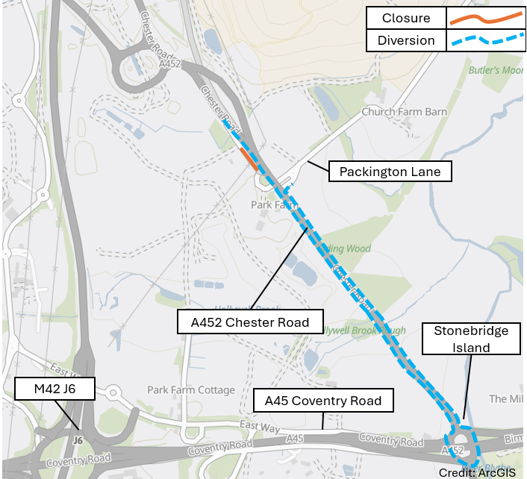

Overnight closures of A452 Chester Road northbound diversion
Please follow the fully signed diversion route and allow more time for your journeys.
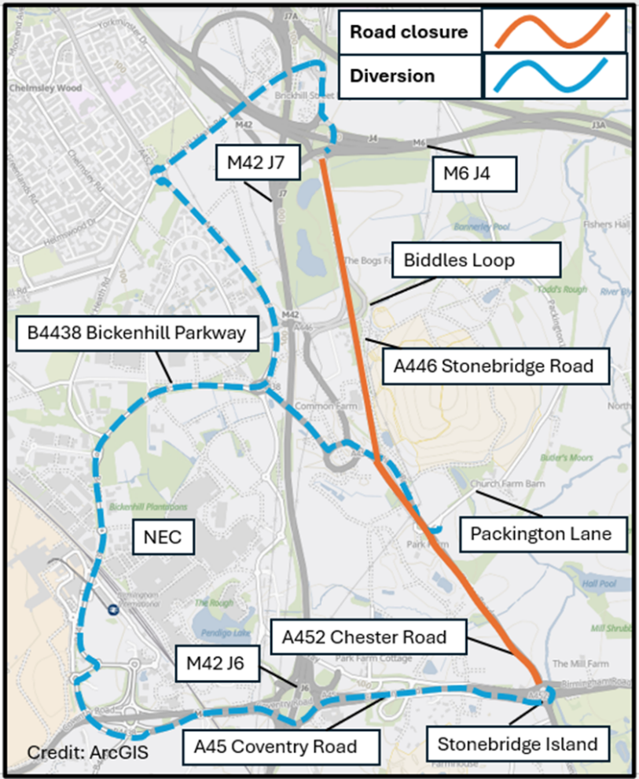



Please contact us if you’d like a free copy of this document in large print, Braille, audio or ‘easy read’ format. You can also contact us for help and information in a different language.
Holding us to account
If you are unhappy for any reason, you can make a complaint by contacting our HS2 Helpdesk team. For more information, visit: www.hs2.org.uk/how-to-complain
We have an independent Residents’ and Construction Commissioner who helps settle disputes and monitors the way in which we manage and respond to complaints about construction.
For more information visit: www.hs2.org.uk/independent-commissioner

