HS2-BBV-26- 2093
AWN
HS2-BBV-26-2045



Notice of lane closure on the southbound A46 near Stoneleigh

Location
A46 southbound near Stoneleigh

Duration
Lane closure will be in place from 12am Saturday 6 June 2026 until 11pm Saturday 6 June 2026 on the southbound A46 near Stoneleigh

What we are doing
We will be carrying out minor earthworks on the verge of A46 bridge.

All our work is subject to final consent from National Highways.

What to expect
An extension of existing Lane 1 closure and some minor delays to your journey. Please see the map on page two.

We are committed to keeping you informed about work on HS2. This includes ensuring you know what to expect and when to expect it, as well as how we can help you. Should you have any questions or concerns about our works you can contact us by:


Freephone 08081 434 434

Minicom 08081 456 472

Email HS2enquiries@hs2.org.uk
Writing to FREEPOST
HS2 Community Engagement


Website www.hs2.org.uk

Keep up to date with what is happening in your local area at
www.hs2.org.uk/in-your-area/
in-your-area-map/

Where we will be working
Map showing location of works on the A46.

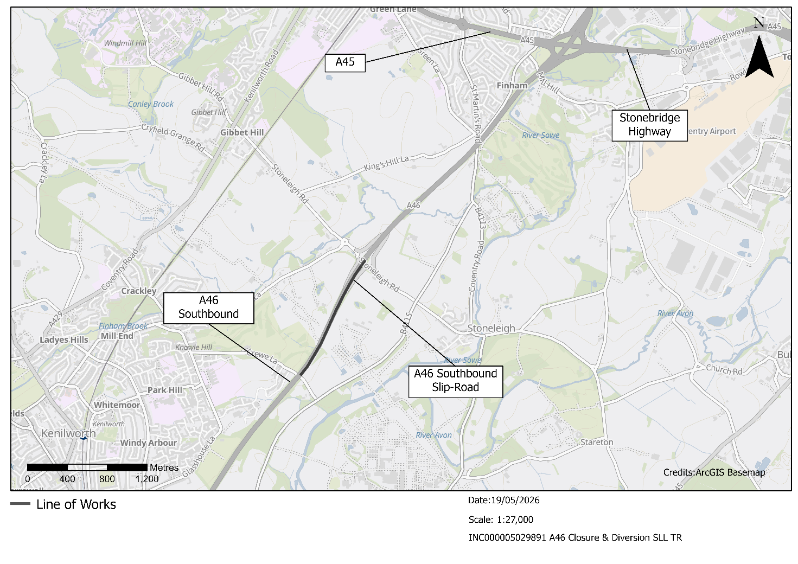

Please contact us if you’d like a free copy of this document in large print, Braille, audio or ‘easy read’ format. You can also contact us for help and information in a different language.
Holding us to account
If you are unhappy for any reason, you can make a complaint by contacting our HS2 Helpdesk team. For more information, visit: www.hs2.org.uk/how-to-complain
We have an independent Residents’ and Construction Commissioner who helps settle disputes and monitors the way in which we manage and respond to complaints about construction.
For more information visit: www.hs2.org.uk/independent-commissioner

