HS2-BCZ – SCP-26-2089



Hoarding and gate installation – New Canal Street South

Location
New Canal Street South

Duration
Monday 1 June to Tuesday 16 June

What we are doing
Installing hoarding and a vehicle access gate.

What to expect
Between the junction of New Canal Street and Fazeley Street, we will be installing replacement hoarding and a vehicle access gate. There will be no impact to vehicles as the road is already closed. However, the existing footway will be temporarily closed. We will put a signed pedestrian diversion in place.

We are committed to keeping you informed about work on HS2. This includes ensuring you know what to expect and when to expect it, as well as how we can help you. Should you have any questions or concerns about our works you can contact us by:


Freephone 08081 434 434

Minicom 08081 456 472

Email HS2enquiries@hs2.org.uk
Writing to FREEPOST
HS2 Community Engagement


Website www.hs2.org.uk

Keep up to date with what is happening in your local area at
www.hs2.org.uk/in-your-area/
in-your-area-map/

Additional information
We recognise that construction work can be disruptive to those living or working nearby. The nature of our work often means some disturbance is unavoidable. We will make every effort to minimise any unnecessary noise. We will closely monitor all noise, vibration, and dust levels to ensure we do not exceed our agreed limits.

Where we will be working
Please see image below showing area of work on New Canal Street and Fazeley Street

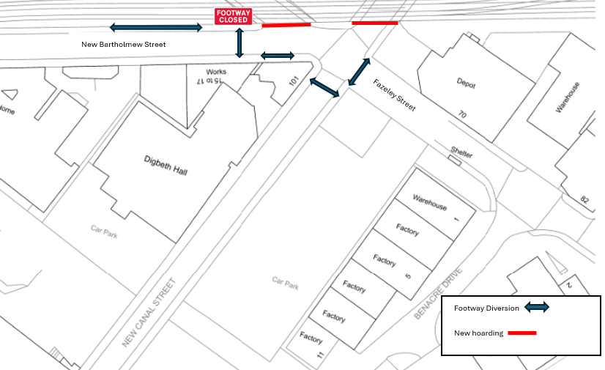

Please contact us if you’d like a free copy of this document in large print, Braille, audio or ‘easy read’ format. You can also contact us for help and information in a different language.
Holding us to account
If you are unhappy for any reason, you can make a complaint by contacting our HS2 Helpdesk team. For more information, visit: www.hs2.org.uk/how-to-complain
We have an independent Residents’ and Construction Commissioner who helps settle disputes and monitors the way in which we manage and respond to complaints about construction.
For more information visit: www.hs2.org.uk/independent-commissioner

