HS2-BCZ – SCP-26-1939



Curzon St station - Pedestrian diversion route signage

April 2026 update

Location
New Canal St, Fazeley Street, New Bartholomew St, Bordesley St, Park St, Moor St Queensway

Duration
These works are now scheduled to take place from Thursday 5 May to Friday 8 May.

What we are doing
Installation of new posts and direction signs at locations listed above.

What to expect
To safely install any new signs or posts, we will need to place barriers around the working area. The footpath will remain open.

We are committed to keeping you informed about work on HS2. This includes ensuring you know what to expect and when to expect it, as well as how we can help you. Should you have any questions or concerns about our works you can contact us by:


Freephone 08081 434 434

Minicom 08081 456 472

Email HS2enquiries@hs2.org.uk
Writing to FREEPOST
HS2 Community Engagement


Website www.hs2.org.uk

Keep up to date with what is happening in your local area at
www.hs2.org.uk/in-your-area/
in-your-area-map/

Additional information
This work is to provide a signed diversion route for pedestrians and cyclists following the long-term temporary closure of New Canal Street. We will use existing posts to display these signs wherever possible to avoid additional unnecessary street furniture.

Where we will be working
We will be working in the following areas: New Canal Street, Fazeley Street, New Bartholomew Street, Bordesley Street, Park Street, Moor Street, Moor Street Queensway

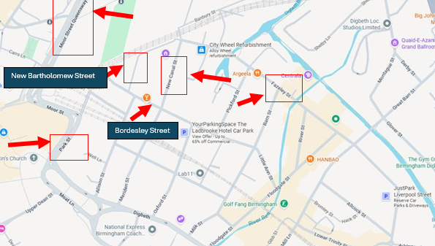

Please contact us if you’d like a free copy of this document in large print, Braille, audio or ‘easy read’ format. You can also contact us for help and information in a different language.
Holding us to account
If you are unhappy for any reason, you can make a complaint by contacting our HS2 Helpdesk team. For more information, visit: www.hs2.org.uk/how-to-complain
We have an independent Residents’ and Construction Commissioner who helps settle disputes and monitors the way in which we manage and respond to complaints about construction.
For more information visit: www.hs2.org.uk/independent-commissioner

