HS2-BCZ – SCP-26-1602



Curzon Street utilities search

Location
Curzon Street

Duration
Monday 2 February 6.30pm to Tuesday 3 February 6am

What we are doing
Carrying out a utility search to identify the depth of any existing services such as Gas, Water and Electric ahead of any construction work in the area.

What to expect
We will use a ground penetration radar trolley to carry out the survey. This is pushed by one operator and an assistant and does not have a motor to propel it. Therefore, it will not create any noise. To carry out this work safely we will put barriers in place on Curzon St to secure the area and some restrictions on the footpath. The Woodman Pub will be open as usual.

We are committed to keeping you informed about work on HS2. This includes ensuring you know what to expect and when to expect it, as well as how we can help you. Should you have any questions or concerns about our works you can contact us by:


Freephone 08081 434 434

Minicom 08081 456 472

Email HS2enquiries@hs2.org.uk
Writing to FREEPOST
HS2 Community Engagement


Website www.hs2.org.uk

Keep up to date with what is happening in your local area at
www.hs2.org.uk/in-your-area/
in-your-area-map/

Additional information
Working hours will be 6:30pm – 6.30am

Where we will be working
Please see image below showing area of work

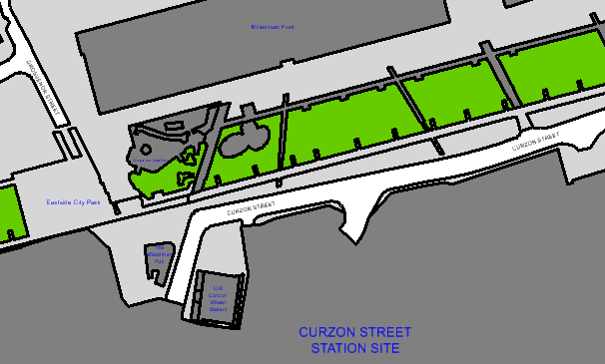

Please contact us if you’d like a free copy of this document in large print, Braille, audio or ‘easy read’ format. You can also contact us for help and information in a different language.
Holding us to account
If you are unhappy for any reason, you can make a complaint by contacting our HS2 Helpdesk team. For more information, visit: www.hs2.org.uk/how-to-complain
We have an independent Residents’ and Construction Commissioner who helps settle disputes and monitors the way in which we manage and respond to complaints about construction.
For more information visit: www.hs2.org.uk/independent-commissioner

