HS2-BCZ – SCP-25-1530



Eastside City Park walkway - gate installation

Location
East Side City Park walkway

Duration
Monday 15 December 2025

What we are doing
We are replacing a section of hoarding with a double metal gate.

What to expect
There will be minor disruption on the footpath along Eastside City Park Walkway during the hours of 9.30am – 3.30pm. Access to the walkway will be remain open at all times.

We are committed to keeping you informed about work on HS2. This includes ensuring you know what to expect and when to expect it, as well as how we can help you. Should you have any questions or concerns about our works you can contact us by:


Freephone 08081 434 434

Minicom 08081 456 472

Email HS2enquiries@hs2.org.uk
Writing to FREEPOST
HS2 Community Engagement


Website www.hs2.org.uk

Keep up to date with what is happening in your local area at
www.hs2.org.uk/in-your-area/
in-your-area-map/

Additional information
Working hours will be 9.30am – 3.30pm

Where we will be working
Please see image below showing area of work

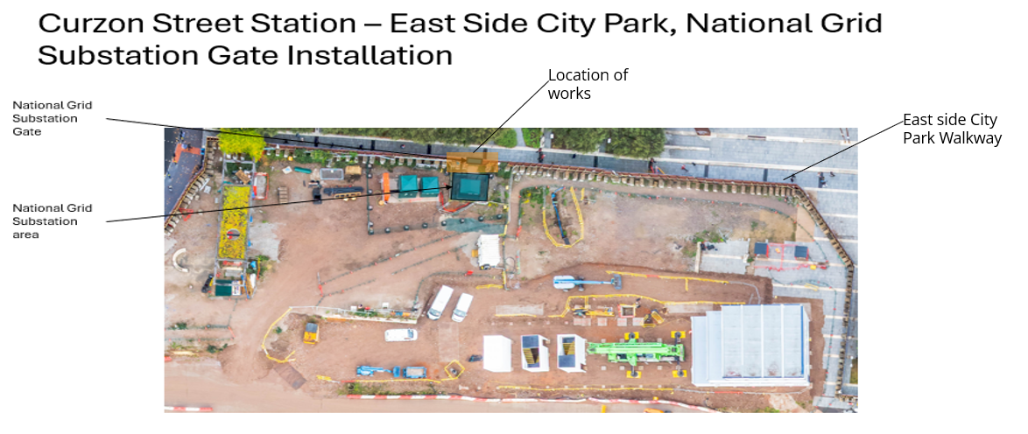

Please contact us if you’d like a free copy of this document in large print, Braille, audio or ‘easy read’ format. You can also contact us for help and information in a different language.
Holding us to account
If you are unhappy for any reason, you can make a complaint by contacting our HS2 Helpdesk team. For more information, visit: www.hs2.org.uk/how-to-complain
We have an independent Residents’ and Construction Commissioner who helps settle disputes and monitors the way in which we manage and respond to complaints about construction.
For more information visit: www.hs2.org.uk/independent-commissioner

