Notice of Park Street hoarding and security gate improvements
October 2025 | www.hs2.org.uk
High Speed Two (HS2) is the new high speed railway for Britain. Mace Dragados is the Construction Partner building the new HS2 station in Birmingham.  What we are doing  We are increasing the height of the hoarding at the highway dead-end section of Park Street, next to the Polish Millennium House and at the junction with Bordesley Street. This is to provide improved security by installing new security features including security fans and roller toppers along the length of the new hoarding.  Park Street and Bordesley Street will remain open during these works.  When will these works take place?  Sunday 26 October 2025, working overnight from 00.15am to 6.30am.  If you have a question about HS2 or our works, please contact our HS2 Helpdesk team on 08081 434 434  or email hs2enquiries@hs2.org.uk |  | When will this start:  Sunday, 26 October  Night time hours  Commence at 00.15am until 06.30 am  What to expect:  • Advance roadside  notices  What we will do:  • keep any disruption to a minimum  • display clear traffic  management  If you have a question  about HS2 or our works,  please contact our HS2  Helpdesk team on 08081  434 434 or email; hs2enquiries@hs2.org.uk  Reference number:

Park Street hoarding improvements

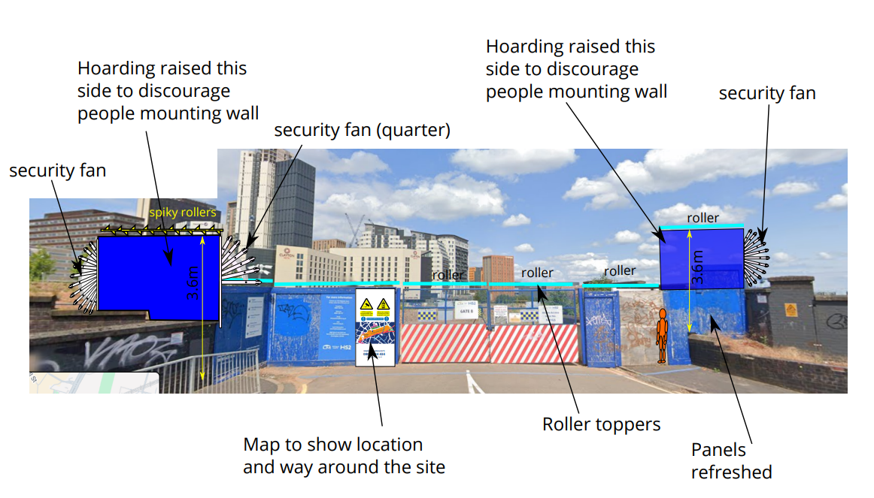

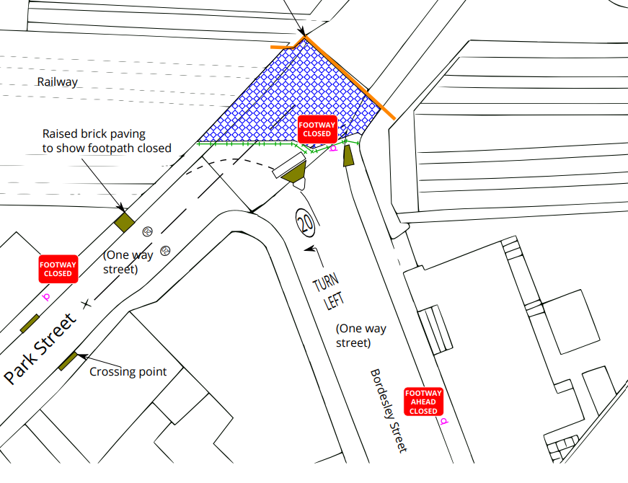



Polish Millenium House

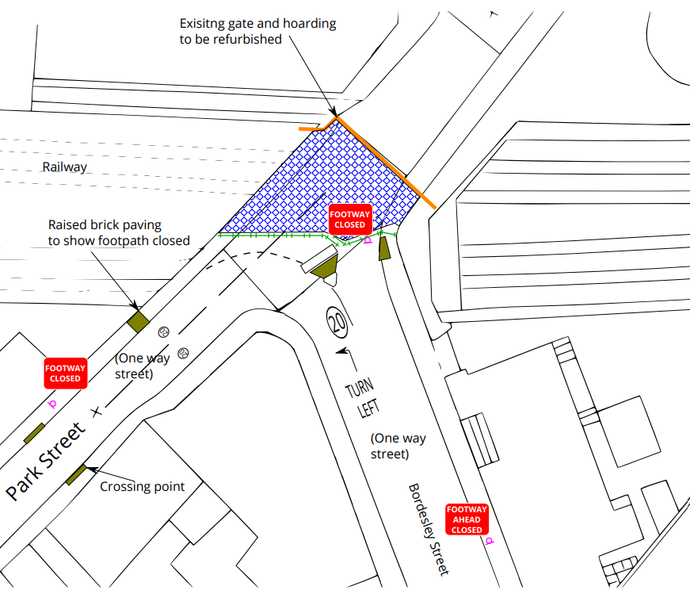

Keeping you informed
We are committed to keeping you informed about work on HS2. This includes ensuring you know what to expect and when to expect it, as well as how we can help you.
The Residents’ Commissioner  The independent Residents’ Commissioner oversees and monitors our commitments to you.  The commissioner’s reports and our responses can be found at www.gov.uk/government/collections/hs2-ltd-residents-commissioner  The Residents’ Commissioner makes sure we fulfil the commitments in the HS2 Community Engagement Strategy (https://bit.ly/3oOA25j).  The Residents’ Commissioner can be contacted on: residentscommissioner@hs2.org.uk  Construction Commissioner  The independent Construction Commissioner regularly meets our Chief Executive Officer to raise any concerns or emerging trends across HS2.  The Construction Commissioner’s role has been developed to monitor the way we manage and respond to construction complaints.  The commissioner mediates on disputes about construction, involving individuals and organisations, that we can’t resolve. The commissioner advises members of the public about how to make a complaint about construction.  The Construction Commissioner can be contacted on: complaints@hs2-cc.org.uk  Property and compensation  You can find out about HS2 and properties along the route by visiting: www.gov.uk/government/collections/hs2-property  Find out if you can claim compensation at: www.gov.uk/claim-compensation-if-affected-by-hs2  Holding us to account  If you are unhappy for any reason you can make a  complaint by contacting the HS2 Helpdesk. For more  details on our complaints process, please visit: www.hs2.org.uk/in-your-area/contact-us/how-to-complain/ |       Contact us  Contact our HS2 Helpdesk team all day, every day of the year on:  Freephone 08081 434 434  Minicom 08081 456 472  Email HS2enquiries@hs2.org.uk  Write to:  FREEPOST  HS2 Community Engagement  Website www.hs2.org.uk  To keep up to date with what is happening in your local area, visit: www.HS2inyourarea.co.uk  Please contact us if you’d like a free copy of this document in large print, Braille, audio or ‘easy read’ format. You can also contact us for help and information in a different language.  HS2 Ltd is committed to protecting personal information. If you wish to know more about how we use your personal information please see our Privacy Notice: https://www.gov.uk/government/publications/high-speed-two-ltd-privacy-notice

Reference number:
High Speed Two (HS2) Limited, registered in England and Wales.
Registered office: Two Snowhill, Snow Hill Queensway, Birmingham B4 6GA.
Company registration number: 06791686. VAT registration number: 888 8512 56

