Notice of lane closure to Jennens Road
October 2025 | www.hs2.org.uk
High Speed Two (HS2) is the new high speed railway for Britain. Mace Dragados is the Construction Partner building the new HS2 station in Birmingham.  What we are doing  We are moving the current coach stop from Curzon Street to Jennens Road.  To put this in place we need remove the old road markings on Jennens Road and repaint new ones. To carry out this work safely, we will close a lane overnight.  We have chosen Jennens Road for the new coach stop to enhance safety for all road users. This will remove coaches away from construction activity taking place on Curzon Street. It will also help maintain a smooth traffic flow throughout the work areas.  What to expect  Jennens Road will remain open, but we will put overnight lane closures in place.  If you have a question about HS2 or our works, please contact our HS2 Helpdesk team on 08081 434 434  or email hs2enquiries@hs2.org.uk |  | When will this start:  Monday 10th November  Overnight hours  Lane closures from 7pm to 7am.  What to expect:  Overnight lane closures on Jennens Road.  Advance roadside signs.  Slight increase in traffic on Jennens Road during the work.  What we will do:  Keep any disruption to a minimum.  Keep one lane open on Jennens Road during the work.  If you have a question  about HS2 or our works,  please contact our HS2  Helpdesk team on 08081  434 434 or email; hs2enquiries@hs2.org.uk  Reference number:  HS2-BCZ – SCP-25-1448

Works to create temporary coach stop on Jennens Road showing land closures and area of works:
Key
Closure Barrier
Signs | 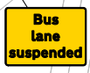
Cone
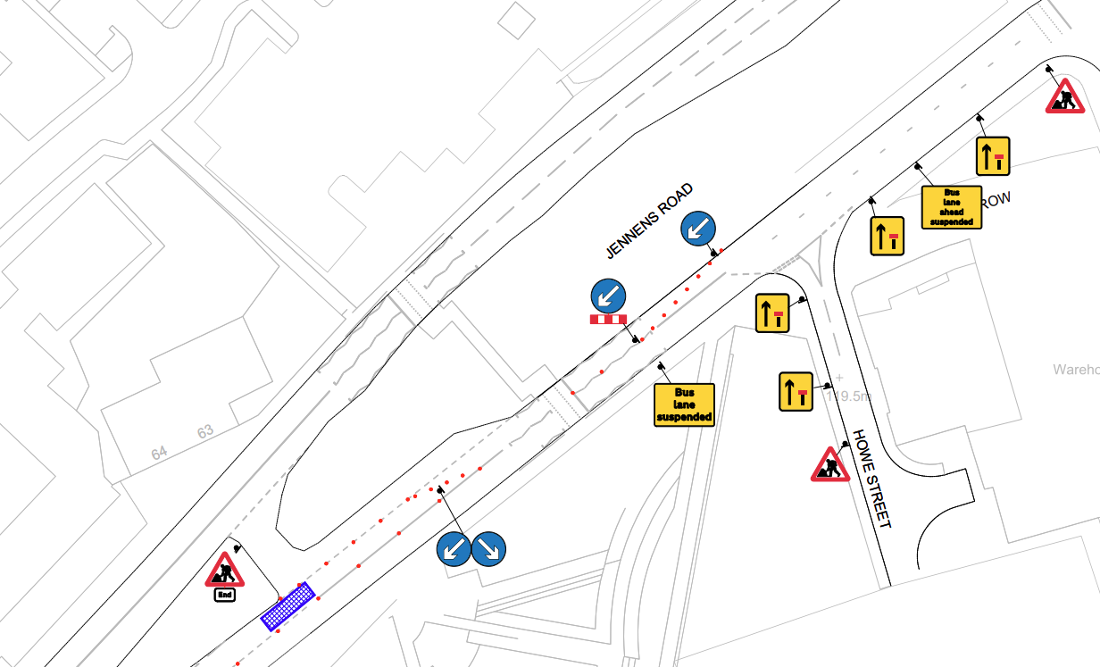

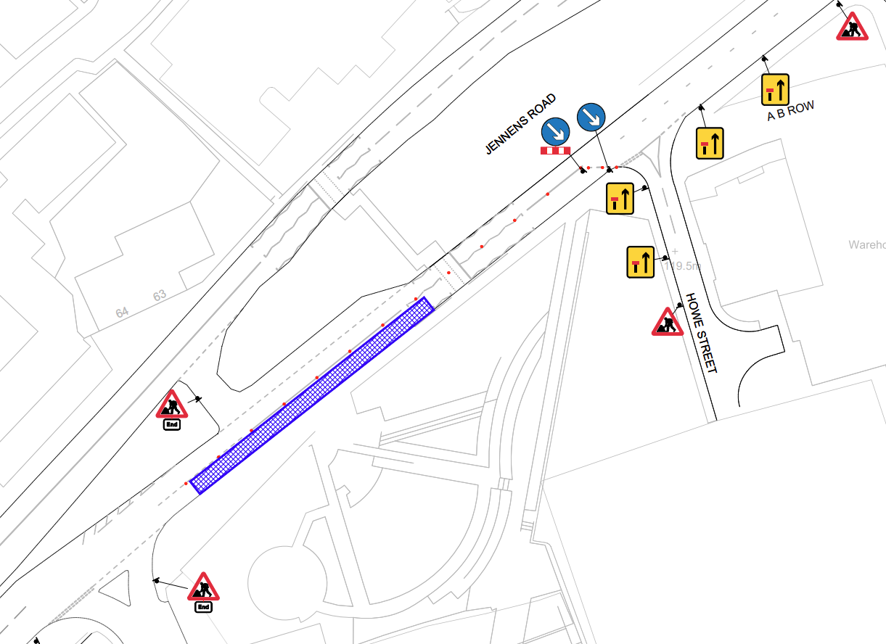

Keeping you informed
We are committed to keeping you informed about work on HS2. This includes ensuring you know what to expect and when to expect it, as well as how we can help you.
The Residents’ Commissioner  The independent Residents’ Commissioner oversees and monitors our commitments to you.  The commissioner’s reports and our responses can be found at www.gov.uk/government/collections/hs2-ltd-residents-commissioner  The Residents’ Commissioner makes sure we fulfil the commitments in the HS2 Community Engagement Strategy (https://bit.ly/3oOA25j).  The Residents’ Commissioner can be contacted on: residentscommissioner@hs2.org.uk  Construction Commissioner  The independent Construction Commissioner regularly meets our Chief Executive Officer to raise any concerns or emerging trends across HS2.  The Construction Commissioner’s role has been developed to monitor the way we manage and respond to construction complaints.  The commissioner mediates on disputes about construction, involving individuals and organisations, that we can’t resolve. The commissioner advises members of the public about how to make a complaint about construction.  The Construction Commissioner can be contacted on: complaints@hs2-cc.org.uk  Property and compensation  You can find out about HS2 and properties along the route by visiting: www.gov.uk/government/collections/hs2-property  Find out if you can claim compensation at: www.gov.uk/claim-compensation-if-affected-by-hs2  Holding us to account  If you are unhappy for any reason you can make a  complaint by contacting the HS2 Helpdesk. For more  details on our complaints process, please visit: www.hs2.org.uk/in-your-area/contact-us/how-to-complain/ |       Contact us  Contact our HS2 Helpdesk team all day, every day of the year on:  Freephone 08081 434 434  Minicom 08081 456 472  Email HS2enquiries@hs2.org.uk  Write to:  FREEPOST  HS2 Community Engagement  Website www.hs2.org.uk  To keep up to date with what is happening in your local area, visit: www.HS2inyourarea.co.uk  Please contact us if you’d like a free copy of this document in large print, Braille, audio or ‘easy read’ format. You can also contact us for help and information in a different language.  HS2 Ltd is committed to protecting personal information. If you wish to know more about how we use your personal information please see our Privacy Notice: https://www.gov.uk/government/publications/high-speed-two-ltd-privacy-notice

Reference number: HS2-BCZ – SCP-25-1448
High Speed Two (HS2) Limited, registered in England and Wales.
Registered office: Two Snowhill, Snow Hill Queensway, Birmingham B4 6GA.
Company registration number: 06791686. VAT registration number: 888 8512 56

