Updated Notice of Temporary Traffic Lights Duddeston Mill Road, Birmingham
September 2025 | www.hs2.org.uk
High Speed Two (HS2) is the new high speed railway for Britain. Balfour Beatty VINCI (BBV) is working in partnership with HS2 Ltd to build the new railway in your area.  Bridge Inspections  Ahead of constructing the new HS2 structures in Birmingham, we will be carrying out inspections on the bridge on Duddeston Mill Road on Monday 22 September.  Temporary Traffic Lights  To carry this work out safely, we will need to put in place temporary traffic lights on a section of Duddeston Mill Road. These will be operational from 9.30am -3.30pm.  Pedestrian access and access to frontages will be maintained throughout.  Finding out more  You can find more details on our events and sign up for news alerts via www.hs2inbirmingham.co.uk.  If you have a question about HS2 or our works, please contact our HS2 Helpdesk team on 08081 434 434  or email hs2enquiries@hs2.org.uk |  |  | Duration of works  Temporary Traffic Lights -Duddeston Mill Road  Monday 22 September  Working hours  Temporary traffic lights operational 9.30am – 3.30pm  What to expect  Temporary traffic lights on a section of Duddeston Mill Road.  What we will do  Ensure that our work areas are safe and secure.  Keep you up to date through www.hs2inbirmingham.co.uk  HS2 Reference:  HS2-BBV-25-1220

Map of Temporary Traffic Lights Duddeston Mill Road, Birmingham | Notification  
www.hs2.org.uk

Map showing location of works

Monday 22 September 2025 9.30am – 3.30pm
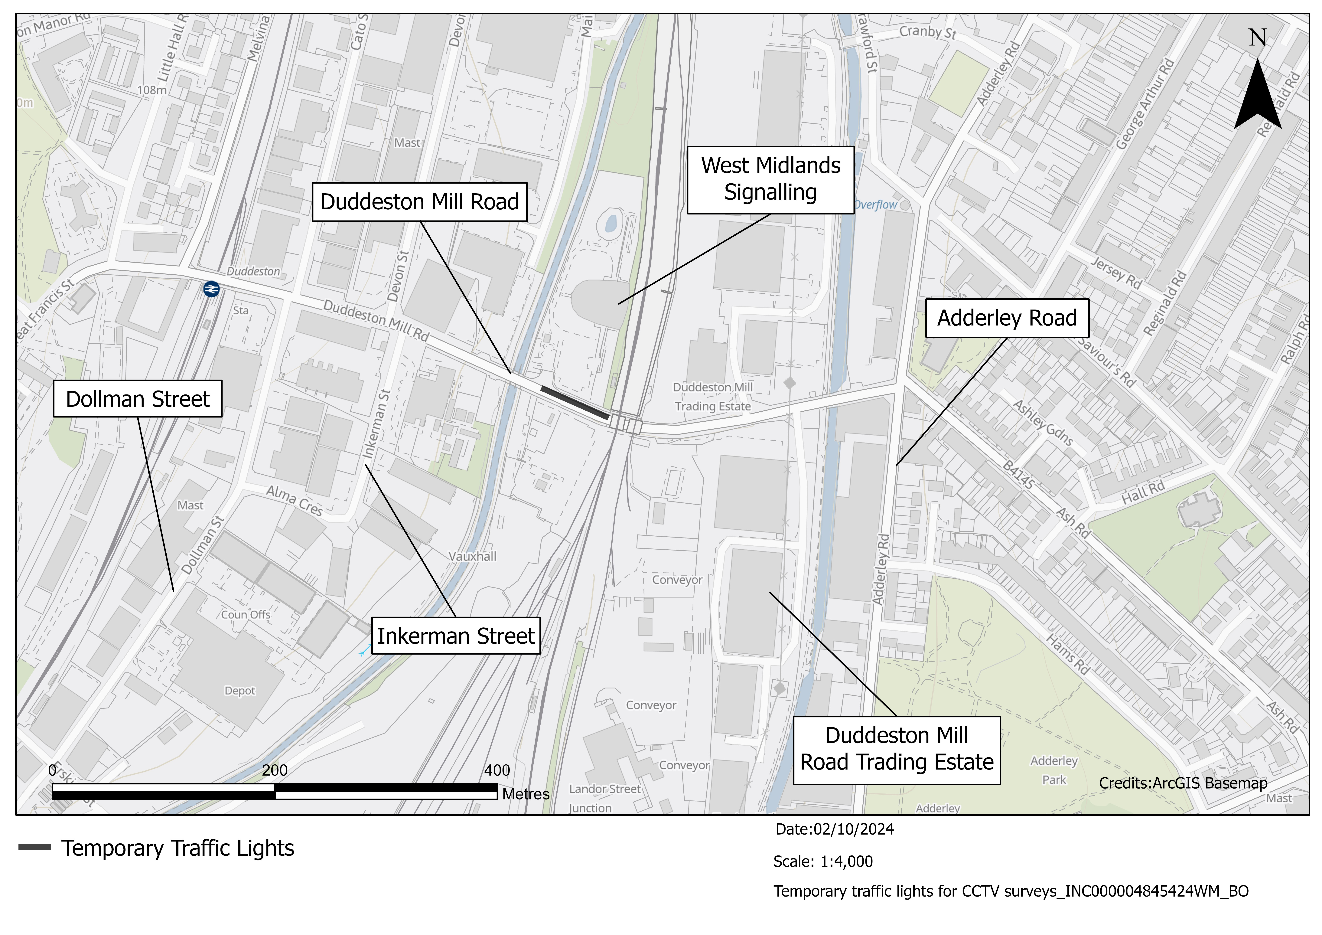

What else is happening
in your area?
www.hs2.org.uk

Contact our HS2 Helpdesk team  Our team is here to listen and respond to your enquiry, complaint or feedback to help us be a good neighbour.  You can contact our Helpdesk team all day, every day of the year on:  Freephone: 08081 434 434  Minicom: 08081 456 472  Email: hs2enquiries@hs2.org.uk  Keep up-to-date with your local community website  To find out more about what’s happening in your area and receive regular email updates, you can sign up to our local community websites at: www.hs2inyourarea.co.uk.  About our Community and Business Funds  We are offering two funds that are available to local communities and businesses between the West Midlands and London, to help with the disruption caused by our construction work. These are the Community and Environment Fund (CEF) and the Business and Local Economy Fund (BLEF).  The CEF is designed to give communities the opportunity to share in the benefits of HS2. It is an allocated fund that communities are able to apply for, to help to support local projects that aim to improve their local area.  The BLEF is designed to support local economies that may be disrupted by the construction of HS2. BLEF grants are for local business support organisations and local authorities to help maintain business activity in local communities.  For more information about each of these funds, including how to apply, please visit: https://www.groundwork.org.uk/hs2funds |   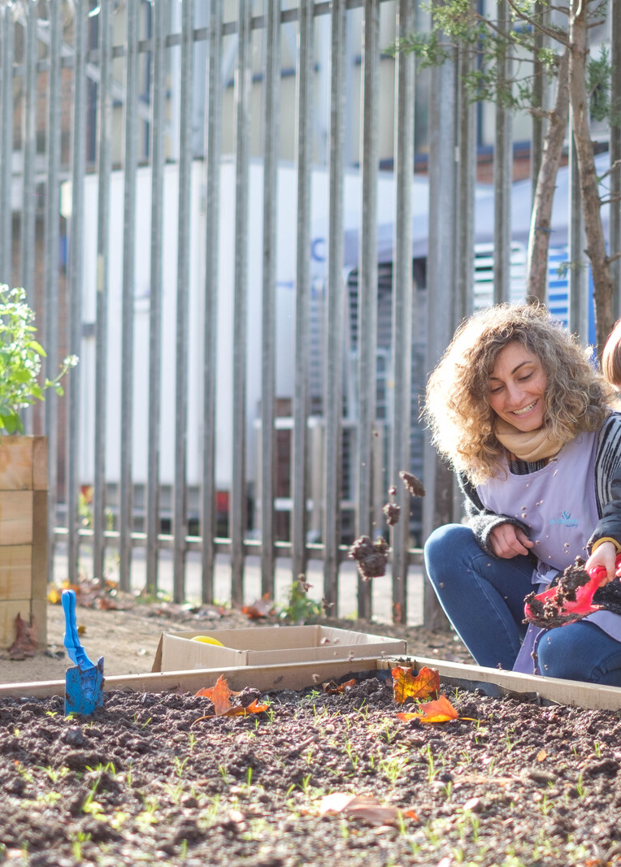

Keeping you informed
We are committed to keeping you informed about work on HS2. This includes ensuring you know what to expect and when to expect it, as well as how we can help you.
The Residents’ Commissioner  The independent Residents’ Commissioner oversees and monitors our commitments to you.  The commissioner’s reports and our responses can be found at www.gov.uk/government/collections/hs2-ltd-residents-commissioner  The Residents’ Commissioner makes sure we fulfil the commitments in the HS2 Community Engagement Strategy (https://bit.ly/3oOA25j).  The Residents’ Commissioner can be contacted on: residentscommissioner@hs2.org.uk  Construction Commissioner  The independent Construction Commissioner regularly meets our Chief Executive Officer to raise any concerns or emerging trends across HS2.  The Construction Commissioner’s role has been developed to monitor the way we manage and respond to construction complaints.  The commissioner mediates on disputes about construction, involving individuals and organisations, that we can’t resolve. The commissioner advises members of the public about how to make a complaint about construction.  The Construction Commissioner can be contacted on: complaints@hs2-cc.org.uk  Property and compensation  You can find out about HS2 and properties along the route by visiting: www.gov.uk/government/collections/hs2-property  Find out if you can claim compensation at: www.gov.uk/claim-compensation-if-affected-by-hs2  Holding us to account  If you are unhappy for any reason you can make a  complaint by contacting the HS2 Helpdesk. For more  details on our complaints process, please visit: www.hs2.org.uk/in-your-area/contact-us/how-to-complain/ |       Contact us  Contact our HS2 Helpdesk team all day, every day of the year on:  Freephone 08081 434 434  Minicom 08081 456 472  Email HS2enquiries@hs2.org.uk  Write to:  FREEPOST  HS2 Community Engagement  Website www.hs2.org.uk  To keep up to date with what is happening in your local area, visit: www.HS2inyourarea.co.uk  Please contact us if you’d like a free copy of this document in large print, Braille, audio or ‘easy read’ format. You can also contact us for help and information in a different language.  HS2 Ltd is committed to protecting personal information. If you wish to know more about how we use your personal information please see our Privacy Notice: https://www.gov.uk/government/publications/high-speed-two-ltd-privacy-notice
Reference number: HS2-BBV-25-1220
High Speed Two (HS2) Limited, registered in England and Wales.
Registered office: Two Snowhill, Snow Hill Queensway, Birmingham B4 6GA.
Company registration number: 06791686. VAT registration number: 888 8512 56

