Updated notice of roadworks on A47 Heartlands Parkway
August 2025 | www.hs2.org.uk
High Speed Two (HS2) is the new high speed railway for Britain. Balfour Beatty VINCI (BBV) is working in partnership with HS2 Ltd to build the new high-speed railway in your area.  Constructing a new Aston Church Road Overbridge  As we build the new high speed railway line in Birmingham, we need to rebuild the existing overbridge on Aston Church Road. We need to do this work because the existing bridge does not currently have enough headroom for the new HS2 trains to pass underneath.  To rebuild the bridge, we currently have Aston Church Road closed to all vehicles.  Partial Road Closure and Lane Closures  We wrote to you previously regarding some upcoming works; however, these were slightly delayed due to some emergency works on the network. As part of the Aston Church Road closure works, we will need to close a section of A47 Heartlands Parkway on Thursday 14 August from 8.00pm to 6.00am. We also need to carry out a series of lane closures on A47 Heartlands Parkway between Saltley roundabout and Star City for approximately four months from Friday 15 August. See maps on overleaf for details.  Diversion route  To keep traffic moving in the area during the full overnight closure, cars will be diverted along A47 Heartlands Parkway, Saltley Viaduct and Washwood Heath Road. Access to businesses and properties will be maintained.  Finding out more  For details about our events where you can find out more sign up for news alerts via www.hs2inbirmingham.co.uk.  If you have a question about HS2 or our works, please contact our HS2 Helpdesk team on 08081 434 434  or email hs2enquiries@hs2.org.uk |  |  | Duration of works  Partial closure on A47 from Thursday 14 August 2025 8.00pm – 6.00am.  Lane closures from Friday 15 August for approximately four months.  What to expect  Partial overnight road closure and lane closures on A47 between Star City Roundabout and Saltley Roundabout.  Diversion routes in place.  What we will do  Ensure that we keep our sites safe and secure.  Keep you updated about any changes via www.hs2inbirmingham.co.uk  Reference number: HS2-BBV-25-1162

Notice of roadworks on A47 Heartlands Parkway | Notification  
www.hs2.org.uk

A47 temporary closure from Star City roundabout to Saltley Viaduct roundabout diversion route

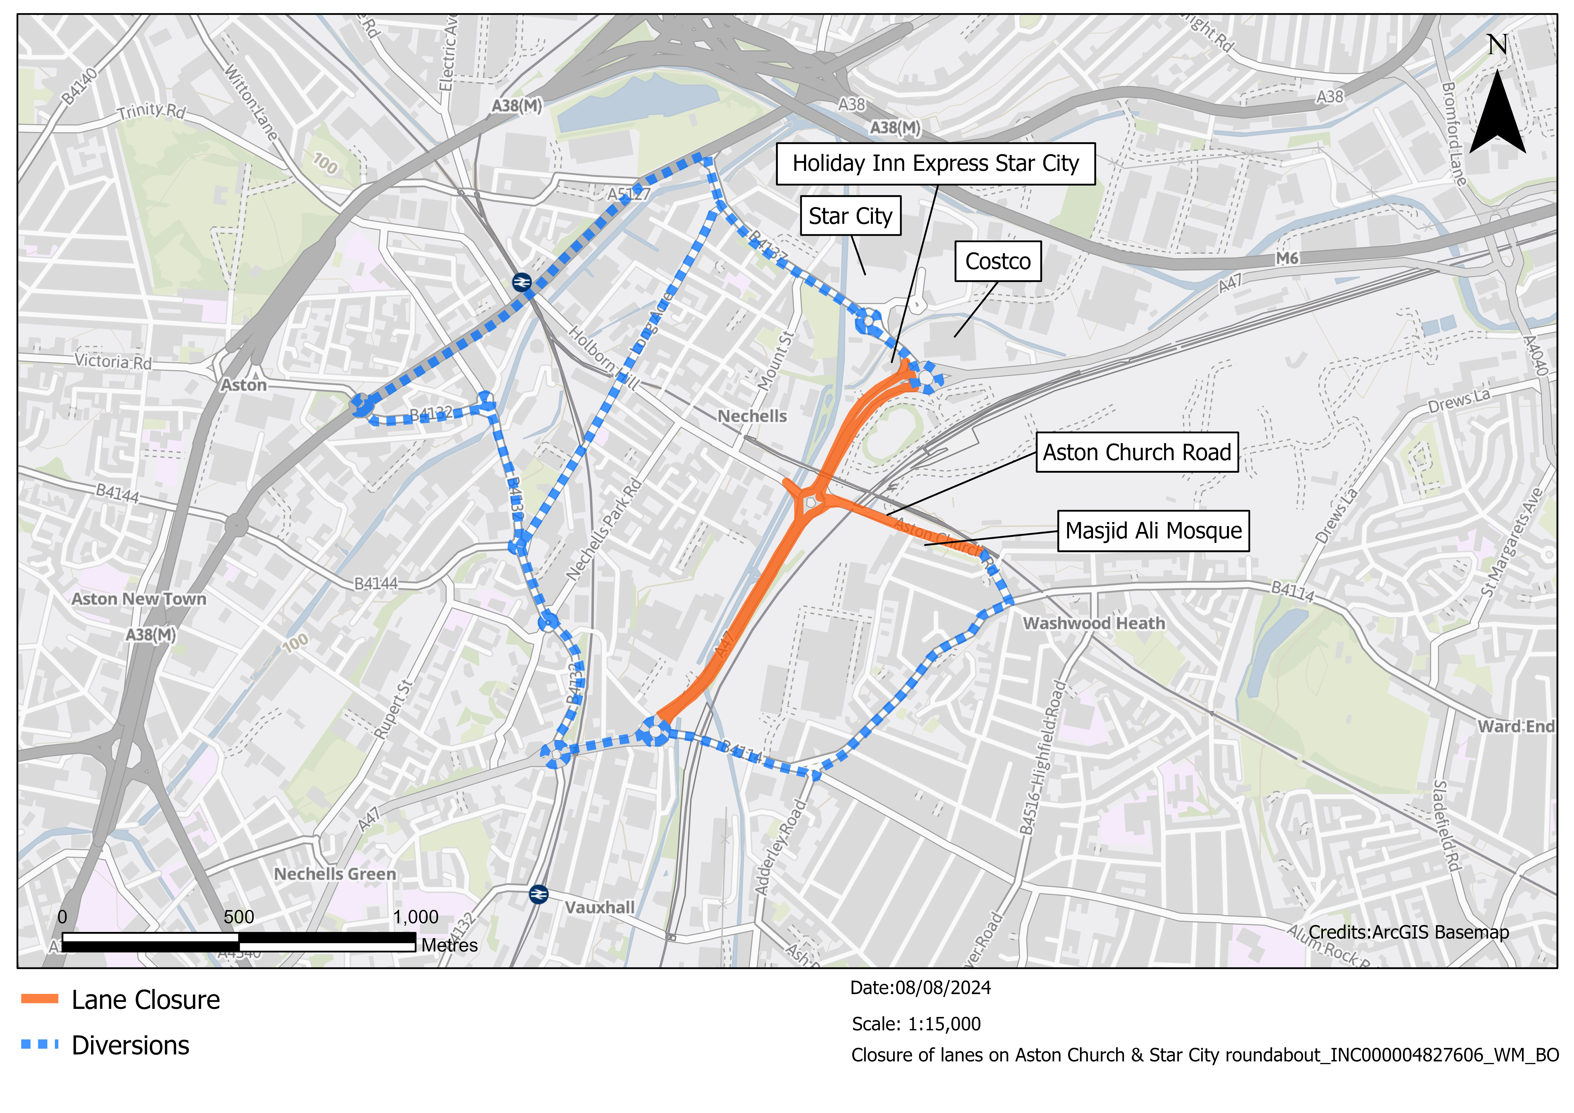

Notice of roadworks on A47 Heartlands Parkway | Notification
www.hs2.org.uk

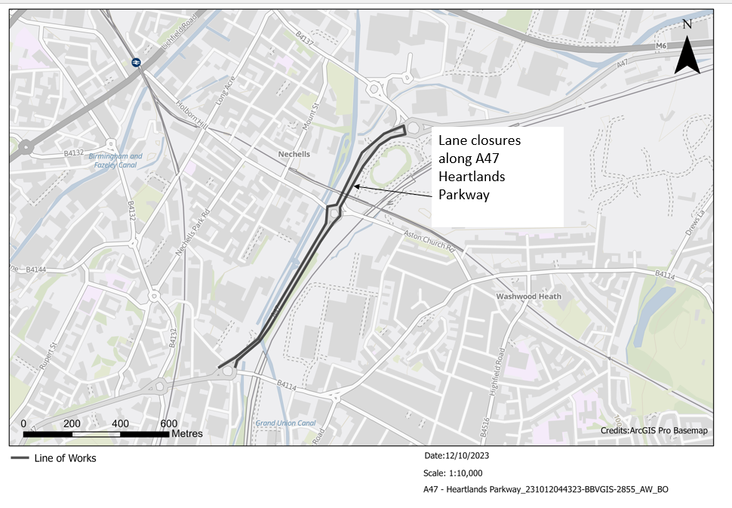

Keeping you informed
We are committed to keeping you informed about work on HS2. This includes ensuring you know what to expect and when to expect it, as well as how we can help you.
The Residents’ Commissioner  The independent Residents’ Commissioner oversees and monitors our commitments to you.  The commissioner’s reports and our responses can be found at www.gov.uk/government/collections/hs2-ltd-residents-commissioner  The Residents’ Commissioner makes sure we fulfil the commitments in the HS2 Community Engagement Strategy (https://bit.ly/3oOA25j).  The Residents’ Commissioner can be contacted on: residentscommissioner@hs2.org.uk  Construction Commissioner  The independent Construction Commissioner regularly meets our Chief Executive Officer to raise any concerns or emerging trends across HS2.  The Construction Commissioner’s role has been developed to monitor the way we manage and respond to construction complaints.  The commissioner mediates on disputes about construction, involving individuals and organisations, that we can’t resolve. The commissioner advises members of the public about how to make a complaint about construction.  The Construction Commissioner can be contacted on: complaints@hs2-cc.org.uk  Property and compensation  You can find out about HS2 and properties along the route by visiting: www.gov.uk/government/collections/hs2-property  Find out if you can claim compensation at: www.gov.uk/claim-compensation-if-affected-by-hs2  Holding us to account  If you are unhappy for any reason you can make a  complaint by contacting the HS2 Helpdesk. For more  details on our complaints process, please visit: www.hs2.org.uk/in-your-area/contact-us/how-to-complain/ |       Contact us  Contact our HS2 Helpdesk team all day, every day of the year on:  Freephone 08081 434 434  Minicom 08081 456 472  Email HS2enquiries@hs2.org.uk  Write to:  FREEPOST  HS2 Community Engagement  Website www.hs2.org.uk  To keep up to date with what is happening in your local area, visit: www.HS2inyourarea.co.uk  Please contact us if you’d like a free copy of this document in large print, Braille, audio or ‘easy read’ format. You can also contact us for help and information in a different language.  HS2 Ltd is committed to protecting personal information. If you wish to know more about how we use your personal information please see our Privacy Notice: https://www.gov.uk/government/publications/high-speed-two-ltd-privacy-notice
Reference number: HS2-BBV-25-1162
High Speed Two (HS2) Limited, registered in England and Wales.
Registered office: Two Snowhill, Snow Hill Queensway, Birmingham B4 6GA.
Company registration number: 06791686. VAT registration number: 888 8512 56

