Notice of works on Banbury Street
November 2024 | www.hs2.org.uk
High Speed Two (HS2) is the new high speed railway for Britain. Mace Dragados is the Construction Partner building the new HS2 station in Birmingham.  Single lane restriction on Banbury Street  As we progress with our piling works for the main station foundations, we need to relocate the turning head on Banbury Street, near the junction of Andover Street. A turning head is a space on a highway designed to allow vehicles to turn without reversing. Turning heads are often used in cul-de-sacs when there isn't enough space for a turning circle.  We will need to reduce Banbury Street to a single lane to provide a safe working zone for our workforce which they readjust the fencing. We will maintain pedestrian and vehicular access to all the businesses on Andover Street and access for small vehicles on Banbury Street.  Traffic management will be in place and will include stop-and-go boards at the junction of Banbury Street and Andover Street.  When will these works take place?  Friday, 21 November to Monday, 25 November 2024, from 8.00 am to 6.00 pm.  What to expect?  - Advanced roadside notice  - Single lane restriction on Banbury Street near the junction of Andover Street  - Stop / Go boards at the junction of Banbury Street and Andover Street  If you have a question about HS2 or our works, please contact our HS2 Helpdesk team on 08081 434 434  or email hs2enquiries@hs2.org.uk |  |  | Duration of works:  2 days  Our working hours are:  Monday to Friday  8am to 6pm  Saturdays  8am to 1pm  What to expect:  • single lane restriction on Banbury Street, near the junction of Andover Street  • Stop-and-Go boards  What we will do:  • keep any disruption to a minimum  • display clear traffic management  If you have a question  about HS2 or our works,  please contact our HS2  Helpdesk team on 08081  434 434 or email; hs2enquiries@hs2.org.uk  Reference number:  HS2-MW-MD-Ph1-Bir-Cur-St-N4-Prog-works-36-18/10/2024

Banbury Street turning head relocation

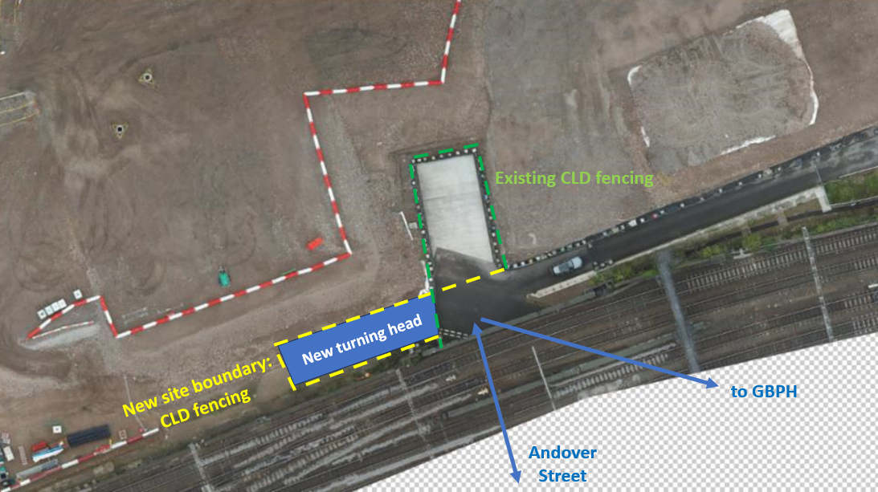

The turning head fencing will be realigned, and the turning head will be relocated to enable piling works for the main station foundations.

We recognise that construction work can be disruptive to those living or working nearby. The nature of our work often means some disturbance is unavoidable, but every effort is made to minimise any unnecessary disturbance. We will closely monitor all noise, vibration, and dust levels to ensure we do not exceed our agreed limits.
Updates will be sent to you regularly outlining the next stages of works in the area including any alterations to the programme. Please note that changes to the programme may occur, and if these changes are likely to cause any disturbance, we will write to you again.
Keeping you informed
We are committed to keeping you informed about work on HS2. This includes ensuring you know what to expect and when to expect it, as well as how we can help you.
The Residents’ Commissioner  The independent Residents’ Commissioner oversees and monitors our commitments to you.  The commissioner’s reports and our responses can be found at www.gov.uk/government/collections/hs2-ltd-residents-commissioner  The Residents’ Commissioner makes sure we fulfil the commitments in the HS2 Community Engagement Strategy (https://bit.ly/3oOA25j).  The Residents’ Commissioner can be contacted on: residentscommissioner@hs2.org.uk  Construction Commissioner  The independent Construction Commissioner regularly meets our Chief Executive Officer to raise any concerns or emerging trends across HS2.  The Construction Commissioner’s role has been developed to monitor the way we manage and respond to construction complaints.  The commissioner mediates on disputes about construction, involving individuals and organisations, that we can’t resolve. The commissioner advises members of the public about how to make a complaint about construction.  The Construction Commissioner can be contacted on: complaints@hs2-cc.org.uk  Property and compensation  You can find out about HS2 and properties along the route by visiting: www.gov.uk/government/collections/hs2-property  Find out if you can claim compensation at: www.gov.uk/claim-compensation-if-affected-by-hs2  Holding us to account  If you are unhappy for any reason you can make a  complaint by contacting the HS2 Helpdesk. For more  details on our complaints process, please visit: www.hs2.org.uk/in-your-area/contact-us/how-to-complain/ |       Contact us  Contact our HS2 Helpdesk team all day, every day of the year on:  Freephone 08081 434 434  Minicom 08081 456 472  Email HS2enquiries@hs2.org.uk  Write to:  FREEPOST  HS2 Community Engagement  Website www.hs2.org.uk  To keep up to date with what is happening in your local area, visit: www.HS2inyourarea.co.uk  Please contact us if you’d like a free copy of this document in large print, Braille, audio or ‘easy read’ format. You can also contact us for help and information in a different language.  HS2 Ltd is committed to protecting personal information. If you wish to know more about how we use your personal information please see our Privacy Notice: https://www.gov.uk/government/publications/high-speed-two-ltd-privacy-notice

Reference number: HS2-MW-MD-Ph1-Bir-Cur-St-N4-Prog-works-36-18/10/2024
High Speed Two (HS2) Limited, registered in England and Wales.
Registered office: Two Snowhill, Snow Hill Queensway, Birmingham B4 6GA.
Company registration number: 06791686. VAT registration number: 888 8512 56

