Notice of temporary closure of Park Lane, Huddlesford

August 2024| www.hs2.org.uk

High Speed Two (HS2) is the new high speed railway for Britain. Balfour Beatty VINCI (BBV) is working in partnership with HS2 Ltd to build the new high-speed railway in your area.  What we are doing  We need to undertake highway works on Park Lane in Huddlesford, Lichfield including installing new signs on the side of the carriageway, painting white lines, clearing vegetation, and undertaking drainage works. As we are unable to undertake our works safely under a single lane closure, we will need to temporarily close the road.  When the work will take place  We will close Park Lane for two days from 9:30am to 3:30pm on 27 August and 28 August 2024. We may be on site one hour before and one hour after to set up and secure the site.  Where we will be working  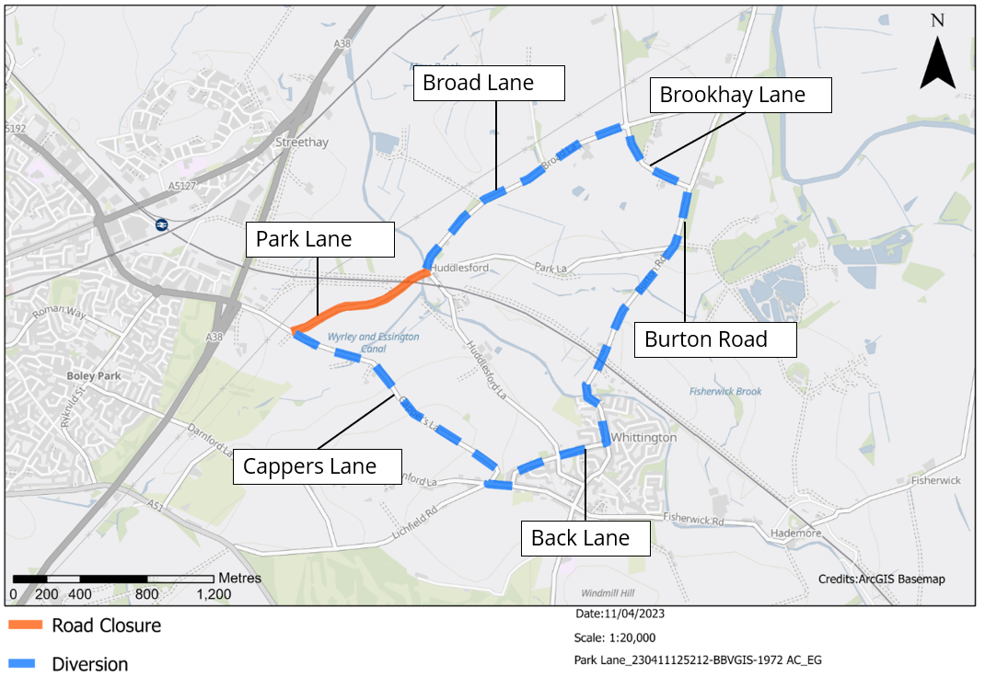  During the closure there will be a fully signed diversion route, shown on the map below.  If you have a question about HS2 or our works, please contact our HS2 Helpdesk team on 08081 434 434  or email hs2enquiries@hs2.org.uk |  |  | Duration of works  Temporary closure of Park Lane in Huddlesford, Lichfield on 27 and 28 August 2024 from 9:30am to 3:30pm  What to expect  Clearly signposted diversion route  Low-level of noise from our machinery  Businesses within Huddlesford will remain open during our works  Please note these works may be subject to change  What we will do  Inform you of any changes or updates in advance via: www.hs2.org.uk/staffordshire

Keeping you informed
We are committed to keeping you informed about work on HS2. This includes ensuring you know what to expect and when to expect it, as well as how we can help you.
The Residents’ Commissioner  The independent Residents’ Commissioner oversees and monitors our commitments to you.  The commissioner’s reports and our responses can be found at www.gov.uk/government/collections/hs2-ltd-residents-commissioner  The Residents’ Commissioner makes sure we fulfil the commitments in the HS2 Community Engagement Strategy (https://bit.ly/3oOA25j).  The Residents’ Commissioner can be contacted on: residentscommissioner@hs2.org.uk  Construction Commissioner  The independent Construction Commissioner regularly meets our Chief Executive Officer to raise any concerns or emerging trends across HS2.  The Construction Commissioner’s role has been developed to monitor the way we manage and respond to construction complaints.  The commissioner mediates on disputes about construction, involving individuals and organisations, that we can’t resolve. The commissioner advises members of the public about how to make a complaint about construction.  The Construction Commissioner can be contacted on: complaints@hs2-cc.org.uk  Property and compensation  You can find out about HS2 and properties along the route by visiting: www.gov.uk/government/collections/hs2-property  Find out if you can claim compensation at: www.gov.uk/claim-compensation-if-affected-by-hs2  Holding us to account  If you are unhappy for any reason you can make a  complaint by contacting the HS2 Helpdesk. For more  details on our complaints process, please visit: www.hs2.org.uk/in-your-area/contact-us/how-to-complain/ |       Contact us  Contact our HS2 Helpdesk team all day, every day of the year on:  Freephone 08081 434 434  Minicom 08081 456 472  Email HS2enquiries@hs2.org.uk  Write to:  FREEPOST  HS2 Community Engagement  Website www.hs2.org.uk  To keep up to date with what is happening in your local area, visit: www.HS2inyourarea.co.uk  Please contact us if you’d like a free copy of this document in large print, Braille, audio or ‘easy read’ format. You can also contact us for help and information in a different language.  HS2 Ltd is committed to protecting personal information. If you wish to know more about how we use your personal information please see our Privacy Notice: https://www.gov.uk/government/publications/high-speed-two-ltd-privacy-notice
Reference number: HS2-MW-BBV-Ph1-Ar-No-N1-Traf-42-27/08/2024
High Speed Two (HS2) Limited, registered in England and Wales.
Registered office: Two Snowhill, Snow Hill Queensway, Birmingham B4 6GA.
Company registration number: 06791686. VAT registration number: 888 8512 56

