Session Plan: Medieval Seal Designing
Overview: | Discover Medieval seals, what they were used for and their imagery. Then, design and decorate your own seal. This activity was inspired by the discovery of a seal matrix in Coleshill.
Learning objectives: | Students will learn how to:  - Explain the difference between a seal and a seal matrix and describe how they were used.  - Match animals or objects to the quality that they symbolise.  - Design a seal using objects, animals and text.
Skills Builder | Students will use the Essential Skill of Listening, Speaking, Problem Solving and Creativity.
Timings | 35-50 minutes, plus 10-15 minutes for an optional extension activity.
Resources | Image of Coleshill seal matrix on page 5 and 3D model on Sketchfab: https://sketchfab.com/3d-models/medieval-seal-from-coleshill-near-birmingham-dcf2a93aec6e44dab0c574f0fa8292b5  Match up table for Medieval symbols and meanings on page 6-7. To look up more symbols and their meaning use: https://www.heraldryandcrests.com/pages/heraldic-symbolism-a-z  Mirrored alphabet sheet on page 8.
Materials | Paper, drawing materials, stencils and scissors.  Optional: mirrors, glue sticks and craft items such as glitter, feathers, pipe cleaners, googly eyes etc.
Coleshill Seal Matrix | This little seal matrix was found in Coleshill during archaeological works for HS2. It dates to the 13th or 14th century and would have been used to authorise documents or to ‘sign’ correspondence, by impressing a personal crest into melted wax. It means that someone at Coleshill was literate and able to write – not such a common ability at this time. The design features a squirrel over clasped hands within a border containing the Latin words ESTO FIDELIS – ‘be faithful’.
Glossary | Seal: a piece of wax or other material that has an individual design stamped into it to authenticate a document or to keep it closed.  Seal Matrix: this is the object that presses into wax to create the seal.  Symbol: a thing that stands for something else.  Symbolism: the use of symbols to represent ideas or qualities.  Crest: a distinctive design representing a family or organisation.
Delivery
Intro  5-10 mins | Key questions  What is a seal? What is a seal matrix? How and why was it used?  What type of things would you see on a seal and why?  Show the Coleshill seal matrix as a 3D model or use the image on page 5. Can you see any imagery on it?  Why do you think there’s a squirrel on the seal matrix? Squirrels were popular pets in the Medieval period! They were sometimes used to represent patience and perseverance.  Does anyone know what words ‘symbol’ or ‘symbolise’ mean?  Can you think of any modern examples of symbols/symbolism? This could tie into learning or modern culture and examples include periodic elements (Fe is the symbol for Iron), superheroes (a spider symbolises Spiderman) or company logos (the M logo symbolises McDonalds).
Activity  5-10 mins | Symbol match up activity.  Use the table on page 6.  As a class or in groups, try to match up animals and objects with their Medieval meaning.  Some objects and animals can have more than on meaning, so students may not agree with the answers. Ask students to explain the reason behind their answers to start a discussion.  The answers are on page 7.
Activity  20 mins | Design your own seal matrix.  Decide what your seal will represent. It could be yourself, your school, your family or group you have joined.  Think of objects and animals that symbolise your chosen subject. Start to design the seal matrix in your head.  Choose the shape of your seal. Medieval seals were often circular, but they could also be other shapes including ovals, triangles, diamonds, shield-shaped or other designs. Use a stencil to draw your chosen shape on to a piece of paper.  Do you want to include any words or letters? The seal matrix is the mirror image of a seal, so remember to spell words backwards and to reverse letters.  Tip: start by writing the word out normally on a spare piece of paper. Hold a mirror next to the word to show the reverse image in the reflection. You can then copy the reverse. You can also use the mirrored alphabet sheet on page 8.  Colour in your seal matrix design and decorate with craft materials.  You could make more seal designs to represent different people or groups.  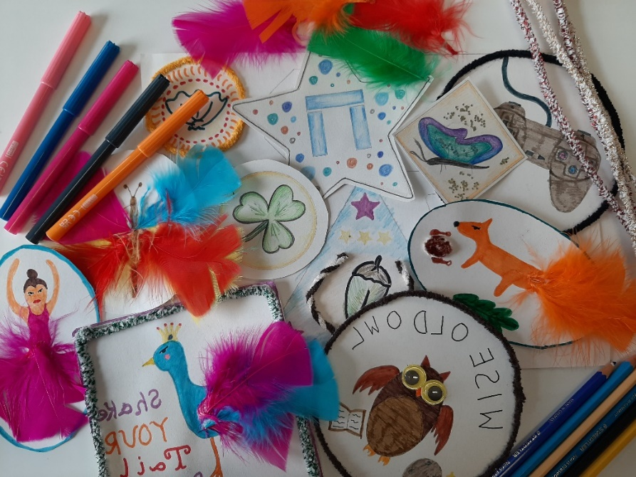
Extension Activity  10-15 mins | Creative writing activity: top secret letter.  Think about why seals were used - to authenticate a document or to keep it closed; to literally ‘seal’ them. If the seal is still intact when the recipient receives the letter, they will know that no one else has read it.  What kind of documents would need a seal? What information might they contain?  When a document is folded and sealed correctly, there is no need for an envelope. Why not have a go at doing this in the classroom with an A4 piece of paper. You can then use the concealed part of the paper to write your letter.  Try writing your own top secret letter to a friend or family member. You can create your own story and some ideas are listed below to get you thinking. Remember, you are writing your letter from the viewpoint of a medieval person.  - The King or Queen has granted you more land. Explain why the land is valuable and what you plan to do with it. Could you build a new manor house or expand your business?  - You are plotting to assassinate the King or Queen. Preparations have been made and you need to tell others how you plan to carry out the task. How can they help you achieve your goal?
Plenary  5-10 mins | Recap key questions.  What is a seal matrix? How and what was it used for?  What type of things would you see on a seal and why?  What does the word symbolise mean?  Students to show other class members their seal matrix designs and talk through why they have chosen certain animals and objects and what they represent.

Coleshill Seal Matrix:

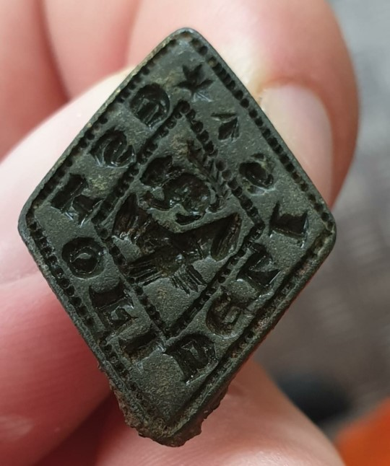

Can you match up the scrambled symbols table below?

Animal or Object |  | What it Symbolises
Lion |  | Medicine
Book |  | Strength
Hand |  | Patience
Owl |  | Peace
Unicorn |  | Learning
Snake |  | Courage
Tower |  | Defence
Dove |  | Protection
Sword |  | Honour in battle
Squirrel |  | Faith
Shield |  | Wisdom

Answers to the match up symbols activity:

Animal or Object | What it Symbolises
Lion | Strength
Book | Learning
Owl | Wisdom
Unicorn | Courage
Snake | Medicine
Tower | Protection
Dove | Peace
Sword | Honour in battle
Shield | Defence
Hand | Faith
Squirrel | Patience

Mirrored alphabet:

