Notice of WPD Construction Works adjacent to the A446 Lichfield Rd
April 2022 www.hs2.org.uk
High Speed Two (HS2) is the new high speed railway for Britain.  What are we doing?  Western Power Distribution (WPD) need to carry out work on their assets located adjacent to the A446 Lichfield Road, part of this work requires the removal of a short section of hedge.  In order to undertake the work safely a lane closure will be in place on a short length of the A446 northbound carriageway, between 9.30am and 3.30pm on Monday 16 May 2022.  How will this impact you?  WPDs Contractors will be working in the area highlighted red on the image below.  The working area will be securely fenced off.  HS2 during the coronavirus pandemic  We are continually reviewing the work on our construction sites in line with Government and Public Health England (PHE) advice on dealing with COVID-19. The Government’s current COVID-19 strategy makes clear that construction activity can continue as long as it complies with this guidance. The health and safety of our workforce and the communities we affect is our key priority. Please be assured that those sites that are currently still working are doing so because they can operate within PHE and construction industry guidelines.  If you have a question about HS2 or our works, please contact our helpdesk on 08081 434 434  or email HS2enquiries@hs2.org.uk |  | Duration  - Work will be undertaken on Monday 16 May 2022  - Our core working hours will be 9:30am to 3:30pm.  - We will be on-site one hour either side of these times for set-up and close-down  What to expect  - There will be slight increase in construction traffic during set up as the contractors mobilise equipment and materials and undertake the work.  Every endeavour will be made to keep disruption to a minimum.  What we will do  - At no time will your services be interrupted. We will complete the work as quickly as possible to avoid disruption and provide you access throughout.

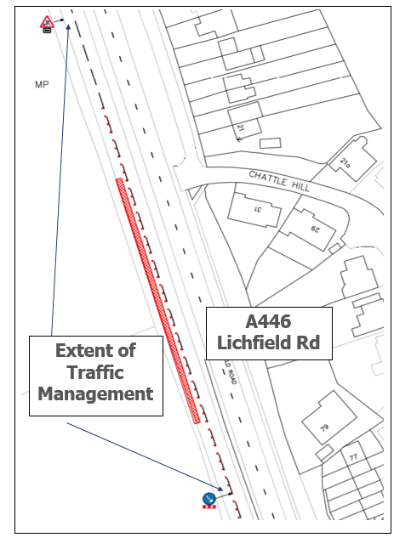

What else is happening in your area?

www.hs2.org.uk

About our Community and Business Funds  We are offering two funds that are available to local communities and businesses between Birmingham and the West Midlands, to help with the disruption caused by our construction work. These are the Community and Environment Fund (CEF) and the Business and Local Economy Fund (BLEF).  The CEF is designed to give communities the opportunity to share in the benefits of HS2. It is an allocated fund that communities can apply for, to help to support local projects that aim to improve their local area.  The BLEF is designed to support local economies that may be disrupted by the construction of HS2. BLEF grants are for local business support organisations and local authorities to help maintain business activity in local communities.  For more information about each of these funds, including how to apply, please visit: https://www.groundwork.org.uk/hs2funds  About our Commonplace websites  The planning and construction of HS2 is a huge operation – it is currently the largest infrastructure project in Europe.  It’s important to us that you are kept up to date about the progress of the Project and any work that may impact you or your community. We have a series of community-focused websites where you can find out what is happening in your local area and sign up for updates about our activities.  Our Commonplace sites currently serve Birmingham, Bucks and Oxfordshire, Cheshire, Euston and Camden, Hertfordshire, Hillingdon, Northamptonshire, Old Oak, Solihull, Staffordshire and Warwickshire. More sites are being prepared to serve other areas.  To find your local Commonplace website, visit: https://hs2.commonplace.is/  For further information about Phase 2a and Phase 2b, visit : https://www.gov.uk/government/organisations/high-speed-two-limited | 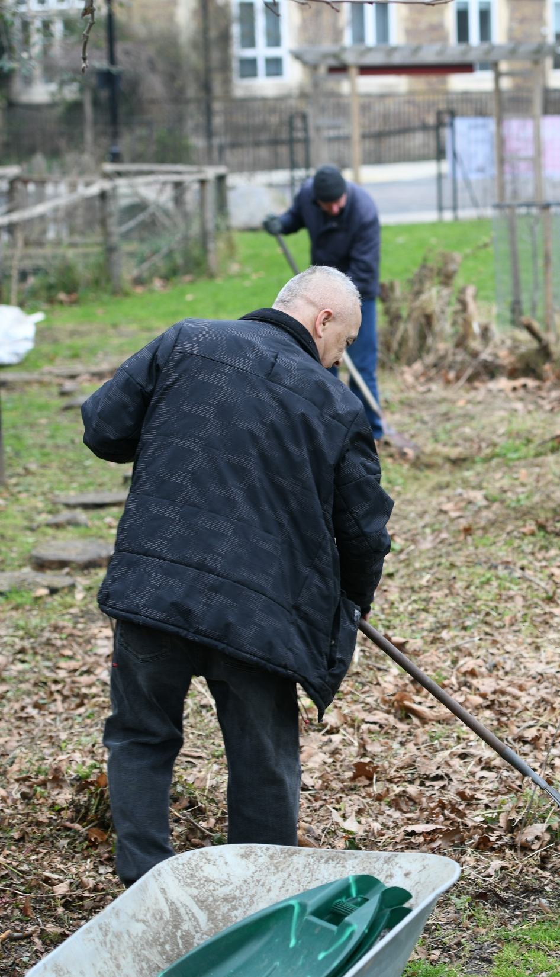  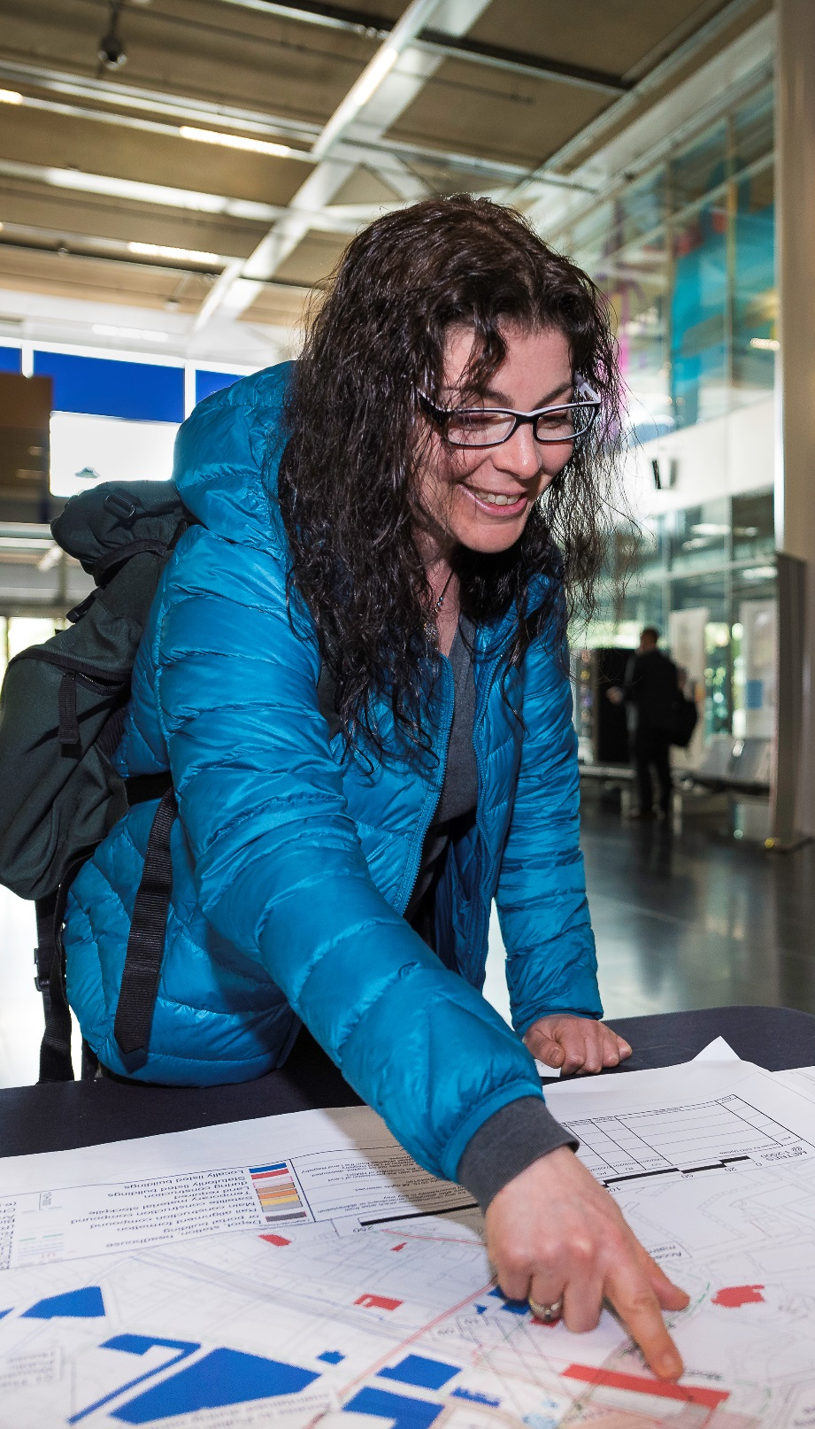

Keeping you informed
We are committed to keeping you informed about work on HS2. This includes ensuring you know what to expect and when to expect it, as well as how we can help.
Residents’ Charter and Commissioner  The Residents’ Charter is our promise to communicate as clearly as we possibly can with people who live along or near the HS2 route.  www.gov.uk/government/publications/hs2-residents-charter  We also have an independent Residents’  Commissioner whose job is to make sure we keep to the promises we make in the Charter and to keep it under constant review. Find reports at:  www.gov.uk/government/collections/hs2-ltd-  residents-commissioner  You can contact the Commissioner at:  residentscommissioner@hs2.org.uk  Construction Commissioner  The Construction Commissioner’s role is to mediate and monitor the way in which HS2 Ltd manages and responds to construction complaints. You can contact the Construction Commissioner by emailing:  complaints@hs2-cc.org.uk  Property and compensation  You can find out all about HS2 and properties along the line of route by visiting:  www.gov.uk/government/collections/hs2-property  Find out if you’re eligible for compensation at:  www.gov.uk/claim-compensation-if-affected-by-hs2  Holding us to account  If you are unhappy for any reason you can make a complaint via the helpline. For more details on our complaints process, please visit our website:  www.hs2.org.uk/how-to-complain |       Contact Us  If you have any questions about this notification of works, please get in touch.  24/7 Freephone 08081 434 434  Minicom 08081 456 472  Email HS2enquiries@hs2.org.uk  Write to:  FREEPOST  HS2 Community Engagement  Website www.hs2.org.uk  To keep up to date with what is happening in your local area, visit: www.hs2.commonplace.is  Please contact us if you’d like a free copy of this document in large print, Braille, audio or easy read. You can also contact us for help and information in a different language.  HS2 Ltd is committed to protecting personal information. If you wish to know more about how we use your personal information please see our Privacy Notice https://www.gov.uk/government/publications/high-speed-two-ltd-privacy-notice

Helpdesk reference: HS2-MW-UT-Ph1--Ar-No-N1-Prog-Works-15-11/04/2022

High Speed Two (HS2) Limited, registered in England and Wales.
Registered office: Two Snowhill, Snow Hill Queensway, Birmingham B4 6GA.
Company registration number: 06791686. VAT registration number: 181 4312 30.

