Notice of utility works, Werner Terrace and Brackley Lane, Calvert
February 2022 | www.hs2.org.uk
High Speed Two (HS2) is the new high speed railway for Britain. We are following Government and Public Health England (PHE) advice on working safely during the pandemic. As we increase face to face engagement, in addition to virtual engagement, we will ensure all events and meetings adhere to the guidelines. The health and safety of our workforce and the communities we work within is our priority. If you have any questions about this, please contact our Helpdesk to find out more.  What are we doing?  Further to our last community notification in December 2021, we are writing to give you an update on the utility diversion works at Calvert.  Junction of Brackley Lane and Werner Terrace  To enable BT and Anglian Water to connect their existing services to the newly diverted cables and pipes, we will need to install 3-way temporary traffic lights on the junction of Brackley Lane and Werner Terrace.  The 3-way temporary traffic lights will be installed on the junction with Brackley Lane and Werner Terrace on:  25 February 2022 until 28 March 2022 (Subject to consents)  The 3- way temporary traffic lights will be operational 24/7 during this section of work.  Throughout these works, there will be restricted residential parking on Werner Terrace and Brackley Lane junction (please see map enclosed).  The public bus stop on Werner Terrace will be suspended whilst we undertake the utility connection and diversion works.  You will be contacted directly by your utility supplier if there are any outages to your supply.  If you have a question about HS2 or our works, please contact our HS2 Helpdesk team on 08081 434 434  or email hs2enquiries@hs2.org.uk |  |  | Duration of works  Until Spring 2022  What to Expect  24/7 temporary traffic lights on the junction of Brackley Lane and Werner Terrace from 25 February 2022 until 28 March 2022  Restricted residential parking  24/7 traffic lights on Brackley Lane from 29 March 2022 until 12 April 2022  Restricted residential parking  What we will do  Work hard to ensure any impacts to residents are kept to a minimum during these works.

Notice of utility works, Werner Terrace and Brackley Lane, Calvert | Notification  
www.hs2.org.uk

What are we doing continued?
Brackley Lane
As part of our demobilisation works from site, we need to remove all plant, materials and reinstate the areas where we have been working. This includes the removal of the two temporary bell mouths on Brackley Lane and reinstatement of the areas.
For this work, we will need to install 3-way temporary traffic lights on Brackley Lane at the junction of Cotswolds Way on:
29 March until 12 April 2022 (Subject to consents)
The 3-way temporary traffic lights will be operational 24/7 during this phase of the work.
Throughout this works, there will be restricted residential parking on the highway (please see map enclosed).
Once these entrances are removed, the temporary traffic lights will be removed.
New substation on Brackley Lane
As part of the enabling works, the existing pole mounted substation on Brackley Lane needs to be replaced ahead of WPD making their new utility connections later in the spring 2022.
The new GRP (Glass reinforced plastic) unit will be 3m x 2.5m and installed on a concrete plinth, once completed and for health and safety purposes it will be locally surrounded by a timber fence.
In spring 2022, WPD will connect their existing services to the newly diverted cables. To do this safely, they will need to install 3-way temporary traffic lights on the junction of Brackley Lane and Werner Terrace.
Once these works are complete a further set of 3- way temporary traffic lights will be installed on Brackley Lane at the junction of Cotswolds Way, this is to allow WPD to make their connections to the new substation.

WPD will keep you informed as to their programme of outages (if required).

Notice of utility works, Werner Terrace and Brackley Lane, Calvert | Notification
www.hs2.org.uk

Parking restrictions in place during Brackley Lane and Werner Terrace
3-way temporary traffic lights
25 February 2022 until 28 March 2022 (subject to consents)

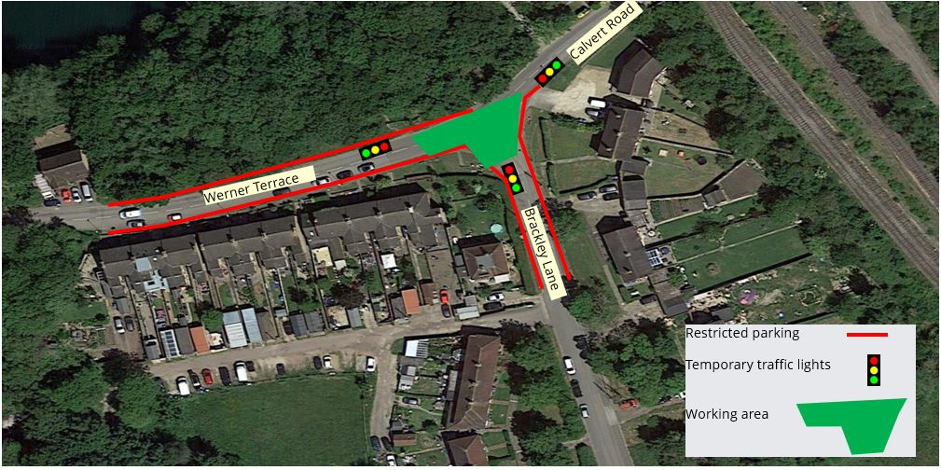

Notice of utility works, Werner Terrace and Brackley Lane, Calvert | Notification
www.hs2.org.uk

Parking restrictions in place along Brackley Lane during 3-way temporary traffic lights
29 March 2022 until 12 April 2022 (Subject to consents)
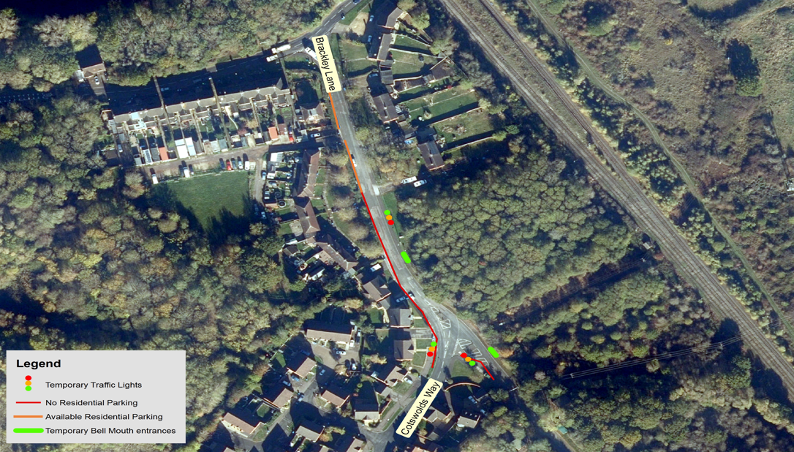

Keeping you informed
We are committed to keeping you informed about work on HS2. This includes ensuring you know what to expect and when to expect it, as well as how we can help you.
The Residents’ Commissioner  The independent Residents’ Commissioner oversees and monitors our commitments to you.  The commissioner’s reports and our responses can be found at www.gov.uk/government/collections/hs2-ltd-residents-commissioner  The Residents’ Commissioner makes sure we fulfil the commitments in the HS2 Community Engagement Strategy (https://bit.ly/3oOA25j).  The Residents’ Commissioner can be contacted on: residentscommissioner@hs2.org.uk  Construction Commissioner  The independent Construction Commissioner regularly meets our Chief Executive Officer to raise any concerns or emerging trends across HS2.  The Construction Commissioner’s role has been developed to monitor the way we manage and respond to construction complaints.  The commissioner mediates on disputes about construction, involving individuals and organisations, that we can’t resolve. The commissioner advises members of the public about how to make a complaint about construction.  The Construction Commissioner can be contacted on: complaints@hs2-cc.org.uk  Property and compensation  You can find out about HS2 and properties along the route by visiting: www.gov.uk/government/collections/hs2-property  Find out if you can claim compensation at: www.gov.uk/claim-compensation-if-affected-by-hs2  Holding us to account  If you are unhappy for any reason you can make a  complaint by contacting the HS2 Helpdesk. For more  details on our complaints process, please visit: www.hs2.org.uk/in-your-area/contact-us/how-to-complain/ |       Contact us  Contact our HS2 Helpdesk team all day, every day of the year on:  Freephone 08081 434 434  Minicom 08081 456 472  Email HS2enquiries@hs2.org.uk  Write to:  FREEPOST  HS2 Community Engagement  Website www.hs2.org.uk  To keep up to date with what is happening in your local area, visit: www.HS2inyourarea.co.uk  Please contact us if you’d like a free copy of this document in large print, Braille, audio or ‘easy read’ format. You can also contact us for help and information in a different language.  HS2 Ltd is committed to protecting personal information. If you wish to know more about how we use your personal information please see our Privacy Notice: https://www.gov.uk/government/publications/high-speed-two-ltd-privacy-notice
Reference number: FUS_AWN_0301HS2-EW-Fusion -Ph1-Ar-Ce-C2-UT-3-08/02/2022
High Speed Two (HS2) Limited, registered in England and Wales.
Registered office: Two Snowhill, Snow Hill Queensway, Birmingham B4 6GA.
Company registration number: 06791686. VAT registration number: 888 8512 56

