**HS2 PHASE 2B WESTERN LEG HYBRID BILL**

Introduction

The means by which the Government will seek authority to build the Phase 2b western leg scheme is by submitting a hybrid Bill to Parliament. Hybrid Bills are not that common, and the process of how a hybrid Bill progresses through Parliament is not widely understood. It is worth noting at the outset that the process is set by Parliament, and not the Government nor HS2 Ltd.

HS2 Ltd has been asked by the Phase 2b western leg Planning Forum to compile the information below to assist local authorities affected by the scheme, and it is correct at the time of writing. However, it should be noted that Parliament has recently undertaken a consultation on possible changes to hybrid Bill procedure and practice and so changes may well be made in due course that will apply to the Phase 2b western leg Bill.

This introduction sets out at a high level the details around petitioning and should be read in conjunction with the rest of the paper to fully understand the processes involved.

*How can the scheme be influenced during the Parliamentary process?*

There are a number of ways in which various parties can seek changes to the proposals in the Bill submitted to Parliament by the Government, depending on the nature of their interest. For those whose property or interests are directly and specially affected the primary opportunity is through the petitioning process.

*What is petitioning?*

A petition in this sense is a request to Parliament to be heard by a Select Committee appointed to consider petitions against the Bill. It is a document, in a specific format, explaining how the petitioner is specially and directly affected by the Bill, setting out their objections to the proposals in the Bill and what action they would like to be taken to reduce the adverse effects the Bill would have on their property or interests or to protect those interests.

*Which petitions are eligible to be heard by a Select Committee?*

Whilst this is for Parliament to decide, the current rules require petitioners who are individuals or businesses to demonstrate that their property or interests are directly and specially affected. Members of Parliament. local authorities and bodies representing interests affected by the Bill may also be heard.

*When can I petition?*

The windows for submitting petitions are set by Parliament and will be published in due course. That said, the first opportunity to petition will be after the Bill receives its Second Reading in the House of Commons, which will be several months after the Bill is deposited.

*What should I include in a petition?*

Describe the reasons you believe you are eligible to petition, how the proposed scheme affects you and your desired outcome.

The Parliamentary process for hybrid Bills

Bills can start their passage through Parliament in either the House of Commons or the House of Lords. Hybrid Bills usually start their passage in the House of Commons, and once they are deposited they must pass through several stages, firstly in the House of Commons and then the House of Lords, to become law:

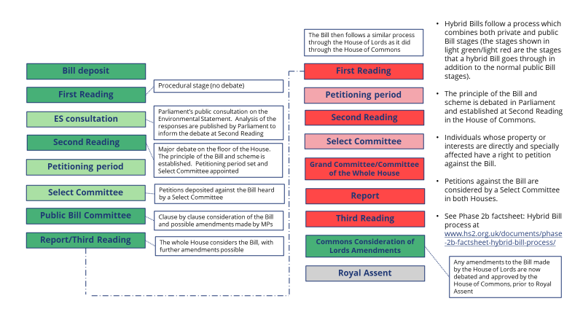

*First Reading in the House of Commons*

A procedural stage, with no debate or vote.

*Consultation on the Environmental Statement*

After the Bill is deposited there will be a consultation on the accompanying Environmental Statement (ES)[1]. Anyone can submit a response to the consultation.

It is Parliament’s consultation, and the aim of the consultation is to ensure that MPs are aware of the public’s views on the environmental impacts of the scheme before they vote on the principle of the Bill at Second Reading. A high level summary of the issues raised in responses to the consultation is produced and published by Parliament’s independent assessor, and so made available to MPs ahead of Second Reading.

**There will be no Government response to the ES consultation, and responses to the consultation will not of themselves lead to changes being made to the scheme.** That said, the consultation responses will give the Government and HS2 Ltd a good idea of the concerns people have about the scheme and the changes that they would like to see made.

*Second Reading*

Second Reading is the first major public Bill stage, and is a debate in the main chamber of the House of Commons where the principle of the Bill and scheme is debated. As with all the other public Bill stages that the Bill will go through – shown in the dark green/dark red in the figure above – there is no direct role during this stage for people other than members of Parliament.

However, people who feel strongly about the Bill or scheme in principle (eg they do not think that the scheme should proceed, or think that it should be replaced by a substantially different scheme or significantly amended), and those whose property or interests are not directly and specially affected by the Bill (see below), have the same right to object to a hybrid Bill as they would to any other public Bill. They can do this by contacting their MP (or a member of the House of Lords, when the Bill is considered there) to seek to influence their consideration of the Bill during one of its public Bill stages, including Second Reading.

**After the Second Reading debate there will usually be a vote on the Bill. If the vote at Second Reading is lost the Bill’s progress through Parliament would come to an end. Other than that, the debate at Second Reading will not of itself lead to changes being made to the scheme, though it can affect what the Select Committee (see below) can in due course consider**. **Once the principle of the Bill is approved at Second Reading it cannot be challenged in the Select Committee proceedings on the Bill.**

*Petitioning in the House of Commons*

A petition against a hybrid Bill is different from a paper petition that people might be asked to sign in the High Street or an e-petition to Parliament supporting a particular cause.

A petition in this sense is a request to Parliament to be heard by a Select Committee on the issues raised in the petition. It is a document, in a specific format, explaining how the petitioner is specially and directly affected by the Bill, setting out their objections to the proposals in the Bill and what action they would like to be taken to reduce the adverse effects the Bill would have on their property or interests or to protect those interests.

Those people whose property or interests are directly and specially affected by the Bill have a right to petition against the Bill. Statutory bodies such as local authorities, including Parish and Town Councils, and environmental groups, for example, are also able to petition, as are MPs with constituencies with works proposed in them.

The Government can challenge the right to be heard of a petitioner if they think that the petitioner is not directly and specially affected, and has in the past published a guide to the right to be heard challenge procedure (the text of which is agreed with Parliament) as well as a detailed note setting out the Government’s position on the right to be heard, and so the approach to be taken on challenging the right to be heard of petitions submitted[2]. The Select Committee appointed to hear petitions will hear and adjudicate on any challenges made by the Government, and so ultimately decide whether it will consider the petition.

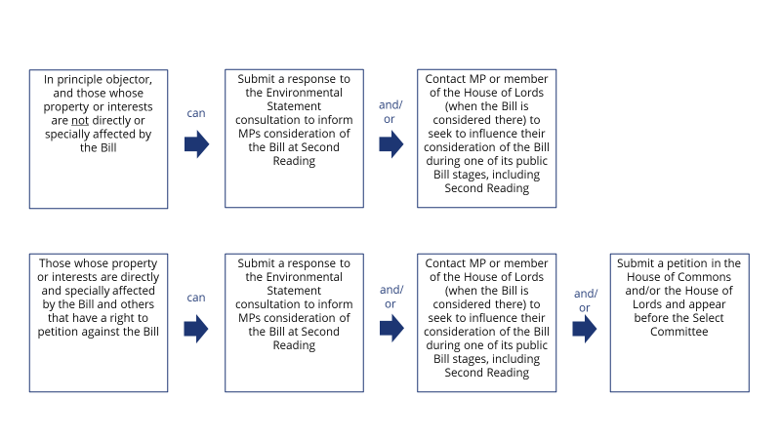

Parliament will issue guidance on petitioning in advance of the petitioning period[3].

**Submitting a petition will not of itself lead to any changes being made to the scheme, as the Select Committee will only consider the issues put to them by petitioners when they appear before them to present their petition.** That said, the Government and HS2 Ltd will seek to engage with petitioners in advance of their appearance before the Select Committee to see if agreement can be reached on the issues raised in their petition, to avoid the need for the petitioner to appear before the Select Committee or at least to reduce the issues raised, and that may include agreeing to make changes to the scheme (see below).

*Select Committee in the House of Commons*

The Select Committee is there to hear the petitions presented to it and to take decisions on the basis of the evidence presented to it by petitioners and the Government.

The Select Committee sits in a quasi-judicial capacity, which means they operate more like a court than a traditional Select Committee that people might have seen on TV, such as the Transport Select Committee or the Public Accounts Committee.

The Select Committee can:

* recommend or direct that amendments be made to the Bill (including specific protective provisions for petitioners), but they cannot reject it outright;
* recommend or direct that the Government give commitments to petitioners to address the concerns presented to them, including on changes to the scheme that can be delivered within the powers in the Bill; and
* recommend or direct that the Government bring forward changes to the scheme that would require additional powers (eg to acquire additional land), in the form of amendments to the Bill known as an Additional Provision (AP). That said, the Select Committee would normally only be able to seek changes to the scheme within the broad route corridor set out in the Bill.

Once it has heard from petitioners and the Government the Select Committee usually issue a Special Report setting out their recommendations. The Government then formally responds to the Select Committee report.

**Changes to the scheme within the broad route corridor set out in the Bill can be made during the House of Commons Select Committee stage.** These can either be the result of agreement reached between petitioners and the Government in advance of an appearance before the Select Committee or the result of a direction from the Select Committee following their consideration of the evidence presented to them by both the petitioner and the Government.

Examples of changes made to the scheme during the House of Commons Select Committee stage on the HS2 Phase 2a Bill included:

* lowering of the Kings Bromley and River Trent viaducts in the Staffordshire area by up to 3 metres, whilst maintaining the highways crossings under the viaducts;
* relocation of the southern portal of Whitmore Heath tunnel further south beyond the A53 Newcastle Road, removing the need to realign the road or construct the A53 overbridge. This change also reduced the loss of ancient woodland from Whitmore Wood;
* additional land for the reconfiguration of Ingestre Park Golf Club to replace the land lost and severed by the HS2 route, enabling the golf course to continue as a community asset;
* additional land for the provision of a replacement facility for Mayfield Children’s Home;
* additional landscape earthworks in the vicinity of the Stone Infrastructure Maintenance Base – Rail (IMB-R), which would further screen and integrate the IMBR into the surrounding landscape;
* additional noise mitigation (through a noise bund at Woodhouse Farm);
* highway and junction modifications and improvements and changes to construction routes to reduce traffic impacts at several locations; and
* realignment of a number of footpaths and bridleways to accommodate concerns raised by landowners.

*Remaining public Bill stages in the House of Commons*

Again, as with Second Reading, there is no direct role during these stages for people other than MPs. **Amendments to the text of the Bill can be made during these stages, but they would not be to the private Bill aspects, and so would not normally change the scheme.**

*First Reading in the House of Lords*

A procedural stage, with no debate or vote. However, the petitioning period in the House of Lords starts at First Reading, rather than at Second Reading.

*Second Reading in the House of Lords*

A debate in the main chamber of the House of Lords where the principle of the Bill and scheme is debated. By convention the House of Lords does not vote on a hybrid Bill at Second Reading, so the Bill cannot be lost at this stage. **Second Reading will not of itself lead to changes being made to the scheme, though it can influence what the Select Committee (see below) can in due course consider**.

*Petitioning in the House of Lords*

Similar to petitioning in the House of Commons. Someone who has petitioned against the Bill in the House of Commons is free to petition again in the House of Lords if they wish to.

*Select Committee in the House of Lords*

Similar to the Select Committee in the House of Commons but with one significant difference. By convention the Select Committee in the House of Lords, as the second House considering the Bill, would not require the Government to bring forward a change to the scheme that would require an AP to deliver, or require that that change be delivered by some other consenting mechanism[4]. **As a result, changes to the scheme requiring additional powers can normally only be made whilst the Bill is in Select Committee in the House of Commons. Changes to the scheme that do not require additional powers can still be made during the House of Lords Select Committee stage.** As in the House of Commons, these can either be the result of agreement reached between petitioners and the Government in advance of an appearance before the Select Committee or the result of a recommendation from the Select Committee following their consideration of the evidence presented to them by both the petitioner and the Government.

*Remaining public Bill stages in the House of Lords*

Again, as in the House of Commons, there is no direct role during these stages for people other than members of the House of Lords. **Amendments to the text of the Bill can be made during these stages, but they would not be to the private Bill aspects, and so would not change the scheme.**

*Commons Consideration of Lords Amendments*

Any amendments to the Bill made in the House of Lords are debated and approved by the House of Commons, prior to Royal Assent.

HS2 Ltd

September 2021

**APPEARING BEFORE A HYBRID BILL SELECT COMMITTEE**

The purpose of petitioning by individuals or businesses is to ensure that those people whose property or interests are directly and specially affected by the Bill have the opportunity to object to the proposals and to have their case heard by the Select Committee, and the role of the Select Committee is to consider such objections carefully and fairly in a quasi-judicial process which allows the petitioner to be heard by the Select Committee, and for a decision to be made about the objection weighing up (amongst other things) any impact on such private interests as against the public interest in the scheme itself.

The petitioning process itself was updated following the passage of the Phase One Bill to make it easier and more accessible. Guidance will be issued by Parliament nearer the time of the petitioning period, and this will explain that a petition needs only:

* say who you, the petitioner(s), are and where you live (or what your business is and where its premises are if it is your business which is affected). If you are petitioning as a group or organisation, the petition should also mention what the group or organisation does and the size of its membership;
* describe how you are specially and directly affected, and explain how the Bill proposals will particularly impact you; and
* state what should be done to reduce the adverse effects the Bill has on you or your property or business and, if possible, how the Bill should be amended to achieve that.

By way of example, the guidance for petitioning against the Phase 2a Bill in the House of Lords can be viewed on Parliament’s website at the following link:

<https://old.parliament.uk/documents/lords-committees/High-Speed-Rail-(West-Midlands-Crewe)-Bill/Guidance-on-petitioning-against-the-HSR-(West-Midlands-Crewe)-Bill-2019.pdf>.

And whilst the petition forms the basis of your case to the Select Committee, so it must include all the objections which you wish to raise (matters can only be raised in Select Committee if they are referred to in the original petition) you do not need to go into your objections in great detail; it is fine to outline them briefly.

To further assist petitioners, a template petition with a clear structure has been produced, and will be made available with the petitioning guidance (see, for example, pages 12 onwards of guidance published by the Private Bill Office in the House of Lords for petitioning against the Phase 2a Bill in the House of Lords in the link above).

In addition, the Phase 2a House of Commons Select Committee produced guidance for petitioners on how to effectively present their petition, and this explained that the Select Committee expected petitioners to spend 10 minutes setting out what they would like, 10 minutes explaining why, and 10 minutes setting out what might be acceptable if the proposed solution was not possible. This guidance can be viewed at the following link: <https://old.parliament.uk/documents/commons-committees/hs2-phase-2a/correspondence/effective-petitioning-17-19.pdf>.

On this basis, whilst petitioners are free to decide whether to engage Counsel, Parliamentary Agents, expert witnesses and to produce detailed technical evidence, preparing and presenting an effective case in Select Committee need not be a lengthy, complex or resource intensive process. Indeed, experience suggests that individuals or local community representatives, such as Parish Councillors, making their case without Counsel, expert witnesses or detailed technical evidence, tend to be very effective in securing the support of the Select Committee.

Furthermore, in practice it typically falls to the Government to respond to the assertions made by the petitioner in making their case, and to produce evidence to support their rebuttal.

Parliament TV recordings of hearings of the Phase One and Phase 2a House of Commons and House of Lords Select Committee can be found [here](https://www.parliamentlive.tv/Search?Keywords=%22%28West+Midlands+-+Crewe%29%22&Member=&MemberId=&House=&Business=&Start=19%2F03%2F2018&End=20%2F05%2F2019). We would encourage people to watch a few sessions to get a feel for what presenting a petition and appearing before the Select Committee involves. You may find it useful to view the hearings for the below listed Parish Councils who appeared before the Phase 2a Select Committees in the House of Commons and/or House of Lords. These recordings can be navigated to by entering the dates of the hearings in the search function:

* Ingestre with Tixall Parish Council appeared on 15 May 2018 (14:45) and 8 May 2019 in the House of Commons, and 29 July 2020 in the House of Lords;
* Kings Bromley Parish Council appeared on 10 May 2018 (AM) and 29 April 2019 (PM) in the House of Commons; and
* Woore Parish Council appeared on 21 May 2018 (4PM) in the House of Commons and 14 September 2020 in the House of Lords.

Finally, the large number of commitments given as part of this process – for example, the published Phase One Register of Undertakings & Assurances contains more than 4,000 undertakings and assurances - and the number and nature of the changes to the schemes that were agreed and brought forward by means of Additional Provisions – some 280 changes to the Phase One scheme and some 195 changes to the Phase 2a scheme – suggest that petitioners are more than capable of securing commitments and/or changes to the scheme. These Registers can be viewed at the following links:

* Phase One Register of Undertakings & Assurances - <https://www.gov.uk/government/publications/high-speed-rail-london-west-midlands-bill-register-of-undertakings-and-assurances>.
* Phase Two Register of Undertakings & Assurances - <https://www.gov.uk/government/publications/hs2-phase-2a-register-of-undertakings-and-assurances>.

1. There will also be a consultation on the impact of the proposals on those with protected characteristics under the Equality Act 2010
2. For example, see the Phase 2a guide and note at <https://www.gov.uk/government/publications/hs2-locus-challenge-guidance>
3. For example, see the petitioning kit produced and published for petitioning against the HS2 Phase 2a Bill in the House of Lords at <https://old.parliament.uk/business/committees/committees-a-z/lords-select/high-speed-rail-west-midlands-crewe-bill-select-committee-lords/petitioning-guidance-17-19/>
4. Were the Bill to start its passage through Parliament in the House of Lords, this convention would apply to the Select Committee in the House of Commons, as it would then be the second House considering the Bill