Notice of Public Rights of Way Closures, Aylesbury
July 2021 | www.hs2.org.uk
High Speed Two (HS2) is the new high speed railway for Britain. We are continually reviewing the works on our construction sites in line with Government and Public Health England (PHE) advice on dealing with COVID-19. You can sign up for regular updates in your local area at www.hs2inbucksandox.co.uk  What are we doing?  As part of our preparatory works and for the safety of the public, we will be closing some footpaths in the area around south west Aylesbury and Stoke Mandeville.  The footpaths which are located close to or cross the construction sites, have to be closed and diverted where possible in the interest of the safety for all users of the public rights of way.  These closures are in order to support the construction of our internal haul road alongside our bridge structures, the Stoke Mandeville Relief Road, the realignment of the Princes Risborough to Aylesbury rail line and the HS2 rail line itself.  When will these works take place?  The works will commence from July in the south west of Aylesbury in the areas close to Southcourt, Sedrup, Bishopstone and Stoke Mandeville.  The footpaths will have closure notices and, where possible, signposted local diversions in place around the construction works until the permanent realignments are completed in 2024.  If you have a question about HS2 or our works, please contact our HS2 Helpdesk team on 08081 434 434  or email hs2enquiries@hs2.org.uk |  |  | Duration of works  Works will commence in July 2021  Normal working hours:  Monday to Friday  8.00am – 6.00pm  Saturdays  8.00am – 1.00pm  Our contractors may be on site for one hour’s start-up and shutdown either side of these times.  What to expect  Varied activities with both quiet and busier periods.  Localised footpath closures and diversions will be in place.  What we will do  Manage any environmental impacts.  Respond promptly to any complaints and take appropriate action.  Take care to respect the community.

Notice of Public Rights of Way Closures, Aylesbury | Notification  
www.hs2.org.uk

Where will the works take place?
South West Aylesbury
The majority of the works will be along the trace of the HS2 trainline. Where possible we will only close a portion of a footpath however this not always practical and, in some cases, we will need to close the entire length. The footpath closures will be signposted, and the map below shows the paths affected and the closure locations. As you will see from the map, footpath SBH/27/1 will remain open however the other footpaths on the map will be closed until late 2024.

The footpaths to be closed in the area south east of the A418 Bicester Road are; SBH/34/1, SBH/19, SMA/17A/1, SMA/16/2, SMA16/1 and SMA/11. A notice regarding the closure of the footpaths northeast of the A418 will be issued in due course once Fusion, the early works contactors have completed their works.

Map of South West Aylesbury diversion route
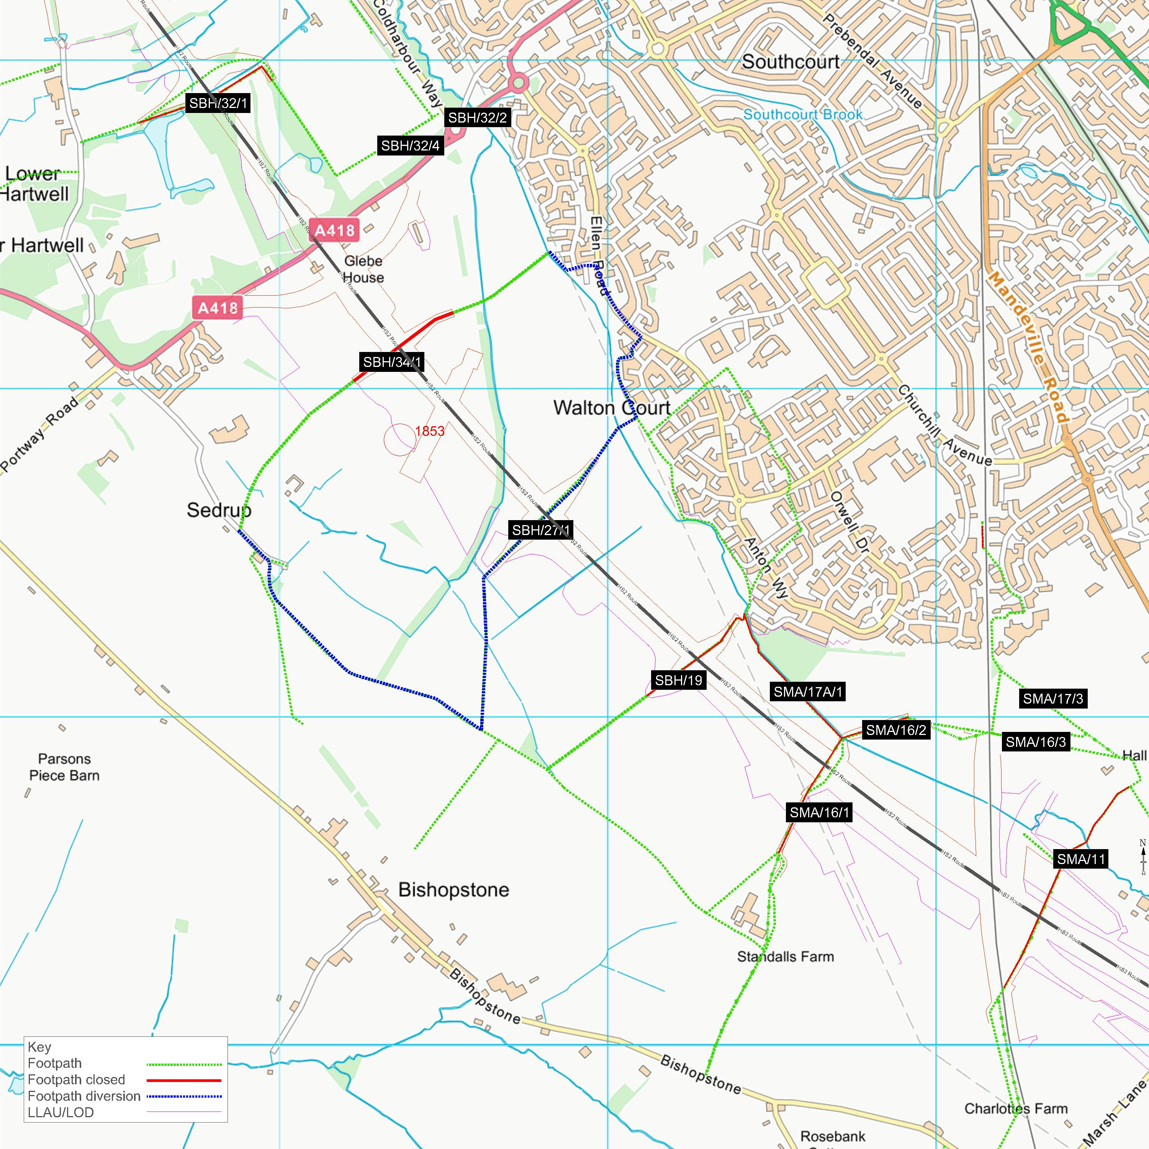

Notice of Public Rights of Way Closures, Aylesbury | Notification
www.hs2.org.uk

Stoke Mandeville
As with the south east of Aylesbury, the footpaths in the Stoke Mandeville area will also be closed until late 2024. The footpaths to be closed are SMA/9/1, SMA/15A/2, SMA/8/3, SMA/8/2, SMA8/1 and ELL/8/1, the map below shows their exact locations and the extents of the closures.

For the safety of the public we are unable to keep open any footpaths that cross the trace of the HS2 line in this area. All of our construction sites will contain large plant and machinery, construction vehicles, HGV’s and large articulated construction site vehicles which is why it is important to segregate our sites from the public. Our team have looked at a number of ways in which diversions could be introduced however in this area, due to the programme of works and locations it has not been possible.

Map of Stoke Mandeville closures
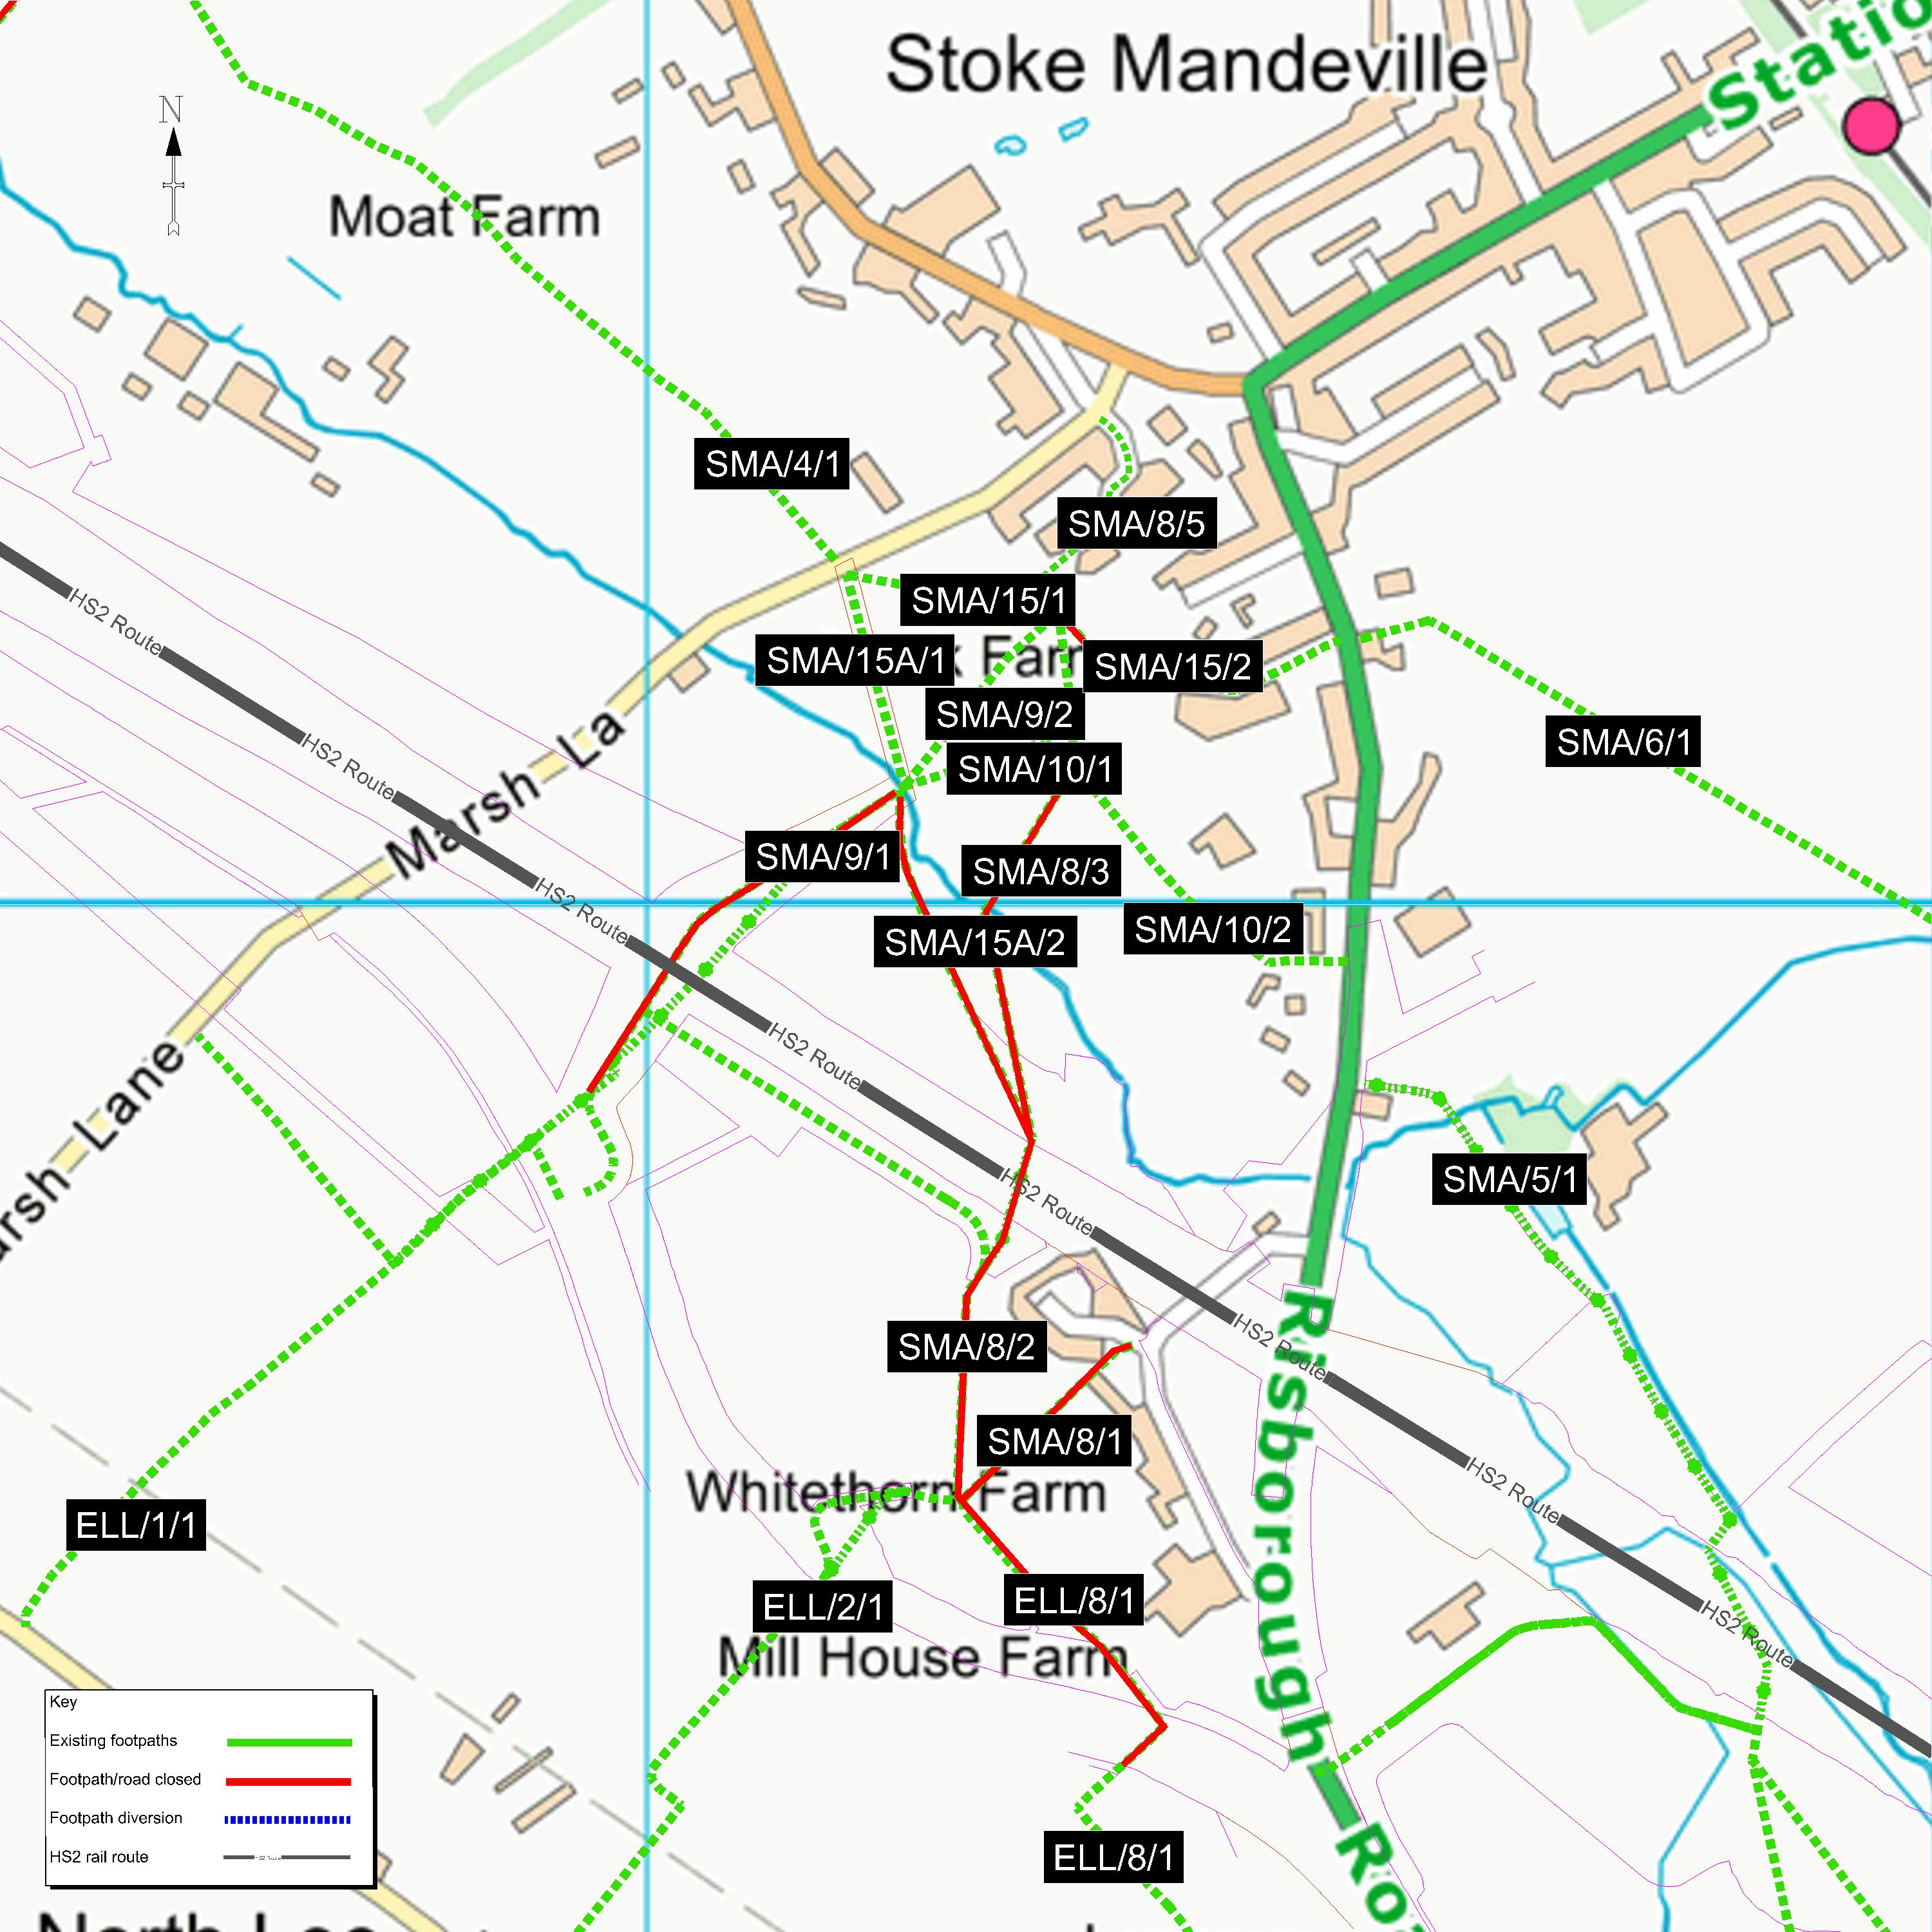

Keeping you informed
We are committed to keeping you informed about work on HS2. This includes ensuring you know what to expect and when to expect it, as well as how we can help.
Residents’ Charter and Commissioner  The Residents’ Charter is our promise to communicate as clearly as we possibly can with people who live along or near the HS2 route.  www.gov.uk/government/publications/hs2-residents-charter  We also have an independent Residents’  Commissioner whose job is to make sure we keep to the promises we make in the Charter and to keep it under constant review. Find reports at:  www.gov.uk/government/collections/hs2-ltd-  residents-commissioner  You can contact the Commissioner at:  residentscommissioner@hs2.org.uk  Construction Commissioner  The Construction Commissioner’s role is to mediate and monitor the way in which HS2 Ltd manages and responds to construction complaints. You can contact the Construction Commissioner by emailing:  complaints@hs2-cc.org.uk  Property and compensation  You can find out all about HS2 and properties along the line of route by visiting:  www.gov.uk/government/collections/hs2-property  Find out if you’re eligible for compensation at:  www.gov.uk/claim-compensation-if-affected-by-hs2  Holding us to account  If you are unhappy for any reason you can make a complaint by contacting our HS2 Helpdesk team. For more details on our complaints process, please visit our website:  www.hs2.org.uk/how-to-complain |       Contact Us  Contact our HS2 Helpdesk team all day, every day of the year on:  Freephone 08081 434 434  Minicom 08081 456 472  Email hs2enquiries@hs2.org.uk  Write to:  FREEPOST  HS2 Community Engagement  Website www.hs2.org.uk  To keep up to date with what is happening in your local area, visit: www.hs2inyourarea.co.uk  Please contact us if you’d like a free copy of this document in large print, Braille, audio or easy read. You can also contact us for help and information in a different language.  HS2 Ltd is committed to protecting personal information. If you wish to know more about how we use your personal information please see our Privacy Notice https://www.gov.uk/government/publications/high-speed-two-ltd-privacy-notice

Reference number: HS2-MW-EK-Ph1-Ar-Ce-C2-Traf-28-07/09/2021

High Speed Two (HS2) Limited, registered in England and Wales.
Registered office: Two Snowhill, Snow Hill Queensway, Birmingham B4 6GA.
Company registration number: 06791686. VAT registration number: 888 8512 56.

