|  | | **Notification** | |
| --- | --- | --- | --- |
| Notice of Utility Works for Curzon Street Station March 2021 | [**www.hs2.org.uk**](http://www.hs2.org.uk) | |  | |
| High Speed Two (HS2) is the new high speed railway for Britain. We are continually reviewing the works on our construction sites in line with Government and Public Health England (PHE) advice on dealing with COVID-19. The Government’s current strategy makes it clear that construction activity can continue as long as it complies with this guidance. Please be assured that only sites that can operate within the guidelines are operational. All sites will remain under constant review  **What we are doing**  We are writing to you to give a brief update and make you aware of the works taking place by Western Power Distribution (WPD) on our behalf.  The proposed work is to undertake trial holes at multiple locations around the vicinity of the HS2 Curzon Street works. This work includes the excavation of material in a segregated works area and reinstatement. All works will be segregated from vehicle or pedestrian access and sign posted. Any changes to footpaths or vehicle routes will be signposted at location in line with agreed traffic management requirements. Once completed all locations will be put back as new. No outages will take place during the works.  These works are in addition to the LMJV works in the same area. All works are being coordinated with LMJV to reduce the impact on all stakeholders.  **How will this affect me?**  **Footpath diversion and lane closure.**  At all work locations, Traffic Management will be in place and this will be coordinated to make sure all appropriate lane closure or footpath diversions are in place prior to the works starting. Work locations are Park Street and Curzon Street.  If you have a question about HS2 or our works, please contact our helpdesk on 08081 434 434 or email HS2enquiries@hs2.org.uk  24/7 Community Freephone Helpline **08081 434 434** |  | | Duration of works  The works will begin week-commencing 01April 2021 and will take two weeks to complete.  What to expect  Traffic management, parking bay closures and footpath diversions along Park Street, and Curzon Street.  Working hours  Normal working hours Monday to Friday 8am to 6pm and Saturday 8am to 1pm. We may also be on site for one hour start up and shutdown outside of these times.  **What we will do**  Manage any impacts, such as traffic and noise with the aim of reducing or removing them. |



24/7 Community Freephone Helpline **08081 434 434**



**Notification**



# Notice of Utility Works for

# Curzon Street Station

February 2021 | [**www.hs2.org.uk**](http://www.hs2.org.uk)

### Map showing the locations of the work

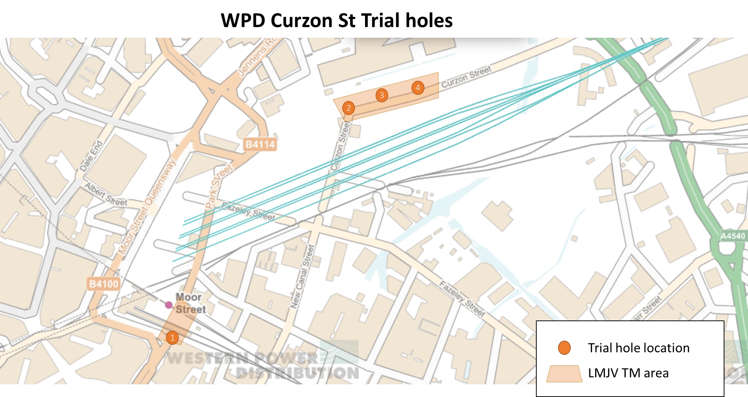



Call our helpdesk team on **0801 434 434**

|  |  |  |
| --- | --- | --- |
| **Keeping you informed** | |  |
| We are committed to keeping you informed about work on HS2. This includes ensuring you know what to expect and when to expect it, as well as how we can help. | |
| **Residents’ Charter and Commissioner**  The Residents’ Charter is our promise to communicate as clearly as we possibly can with people who live along or near the HS2 route.  www.gov.uk/government/publications/hs2-residents-charter  We also have an independent Residents’  Commissioner whose job is to make sure we keep to the promises we make in the Charter and to keep it under constant review. Find reports at:  www.gov.uk/government/collections/hs2-ltd-  residents-commissioner  You can contact the Commissioner at:  residentscommissioner@hs2.org.uk  **Construction Commissioner**  The Construction Commissioner’s role is to mediate and monitor the way in which HS2 Ltd manages and responds to construction complaints. You can contact the Construction Commissioner by emailing:  complaints@hs2-cc.org.uk  **Property and compensation**  You can find out all about HS2 and properties along the line of route by visiting:  www.gov.uk/government/collections/hs2-property  Find out if you’re eligible for compensation at:  [www.gov.uk/claim-compensation-if-affected-by-hs2](http://www.gov.uk/claim-compensation-if-affected-by-hs2)  **Holding us to account**  If you are unhappy for any reason you can make a complaint via the helpline. For more details on our complaints process, please visit our website:  www.hs2.org.uk/how-to-complain | **Contact Us**  If you have any questions about this notification of works, please get in touch.  24/7 Freephone **08081 434 434**  Minicom **08081 456 472**  Email **HS2enquiries@hs2.org.uk**  Write to:  **FREEPOST**  **HS2 Community Engagement**  Website [**www.hs2.org.uk**](http://www.hs2.org.uk)  To keep up to date with what is happening in your local area, visit: **www.hs2.commonplace.is**  Please contact us if you’d like a free copy of this document in large print, Braille, audio or easy read. You can also contact us for help and information in a different language.  HS2 Ltd is committed to protecting personal information. If you wish to know more about how we use your personal information please see our Privacy Notice https://www.gov.uk/government/publications/high-speed-two-ltd-privacy-notice | |

Reference number: HS2-EW-OTH-UT-Ph1-Bir-Cur-St-N4-UT-9-23/01/2021

High Speed Two (HS2) Limited, registered in England and Wales.

Registered office: Two Snowhill, Snow Hill Queensway, Birmingham B4 6GA.

Company registration number: 06791686. VAT registration number: 181 4312 30.